|  |  |  |  |  |  |
| --- | --- | --- | --- | --- | --- |
| **Declaration** |  | | | | |
| Questions in this exercise are intentionally complex and could be convoluted or confusing. This is by design and to simulate real life situations where customers seldom give crystal clear requirements and ask unambiguous questions. | | | | | |
|
|
| I have read the above statement and agree to these conditions | | | | | |
| I AGREE | Pratibha Dixit | | | | |
| <Enter your name above this line to indicate that you are in agreement> | | | | |
|  |  |  |  |  |  |
|  |  |  |  |  |  |
| **Instructions** |  |  |  |  |  |
| Every screenshot requested in this workbook is compulsory and carries 0.5 marks | | | | | |
| Your AWS account ID must be clearly visible in every screenshot using the AWS console; missing id or using someone else's id is not permitted. Such cases will be considered as plagiarism and severe penalty will be imposed. | | | | | |
| All screenshots must be in the order mentioned under "Expected Screenshots" for every step | | | | | |
| DO NOT WAIT UNTIL THE LAST MINUTE. | | | | | |
| The file should be renamed in the format BATCH_FIRSTNAME_LASTNAME_PROJECT1.  For example: IITR_FSD_VIJAY_DWIVEDI_PROJECT1.docx | | | | | |
|  |  |  |  |  |  |
|  |  |  |  |  |  |
| **Resource Clean Up** | |  |  |  |  |
| Cloud is always pay per use model and all resources/services that we consume are chargeable. Cleaning up when you’ve completed your lab or project is always necessary. This is true whether you’re doing a lab or implementing a project at your workplace. | | | | | |
| After completing the lab, make sure to delete each resource created in reverse chronological order. | | | | | |

**Scenario**

Team communication and instant messaging solutions are an integral part of any business environment today. As of 2020, the total number of users of Slack and Microsoft Teams exceeded 20 million.

Some organizations might have compliance policies in place which do not allow them to use services managed by third parties. They will prefer solutions that can be managed and hosted on servers controlled by them. The same will extend to communication solutions as well.

**Architecture diagram**

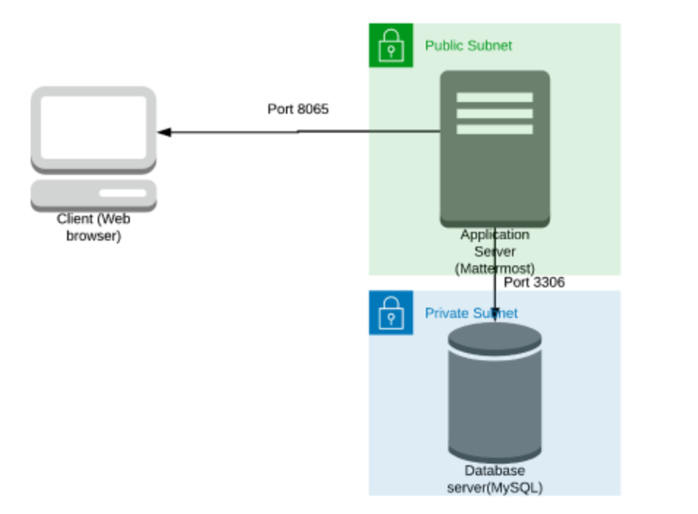

|  |  |
| --- | --- |
| **Architecture Implementation** | |
| 1 | Implement 2 different subnets (one public and the other private) in a custom VPC |
| 2 | Install and configure MySQL on an Amazon Linux 2 instance on the private subnet using the instructions provided. (Hint: Use a bastion host and a NAT gateway) |
| 3 | Install and configure Mattermost on an Amazon Linux 2 instance on the public subnet using the provided instructions. |
| 4 | Configure the security groups to allow the ports as shown in the architecture. |
| 5 | Test the installation by accessing the IP of the public instance in a browser via the port 8065. |

**Step 1: VPC and Subnet Creation**

|  |  |  |  |
| --- | --- | --- | --- |
| Step number | A |  |  |
| Step name | Creation of VPC |  |  |
| Instructions | 1) Navigate to VPC using the Services button at the top of the screen  2) Select "Your VPCs" on the left side of the screen  3) Click on "Create VPC"  4) Enter the following fields :  Name: Project 1 VPC  IPv4 CIDR Block : 10.0.0.0/16  The rest of the options can be ignored  5) Select "Create VPC"  6) Select the VPC and click on Actions->Edit DNS hostnames  7) Enable DNS hostnames and click on Save |  |  |
| Expected screenshots | 1. Created VPC with properties visible |  |  |

**<Insert Screenshot a(1) here>**

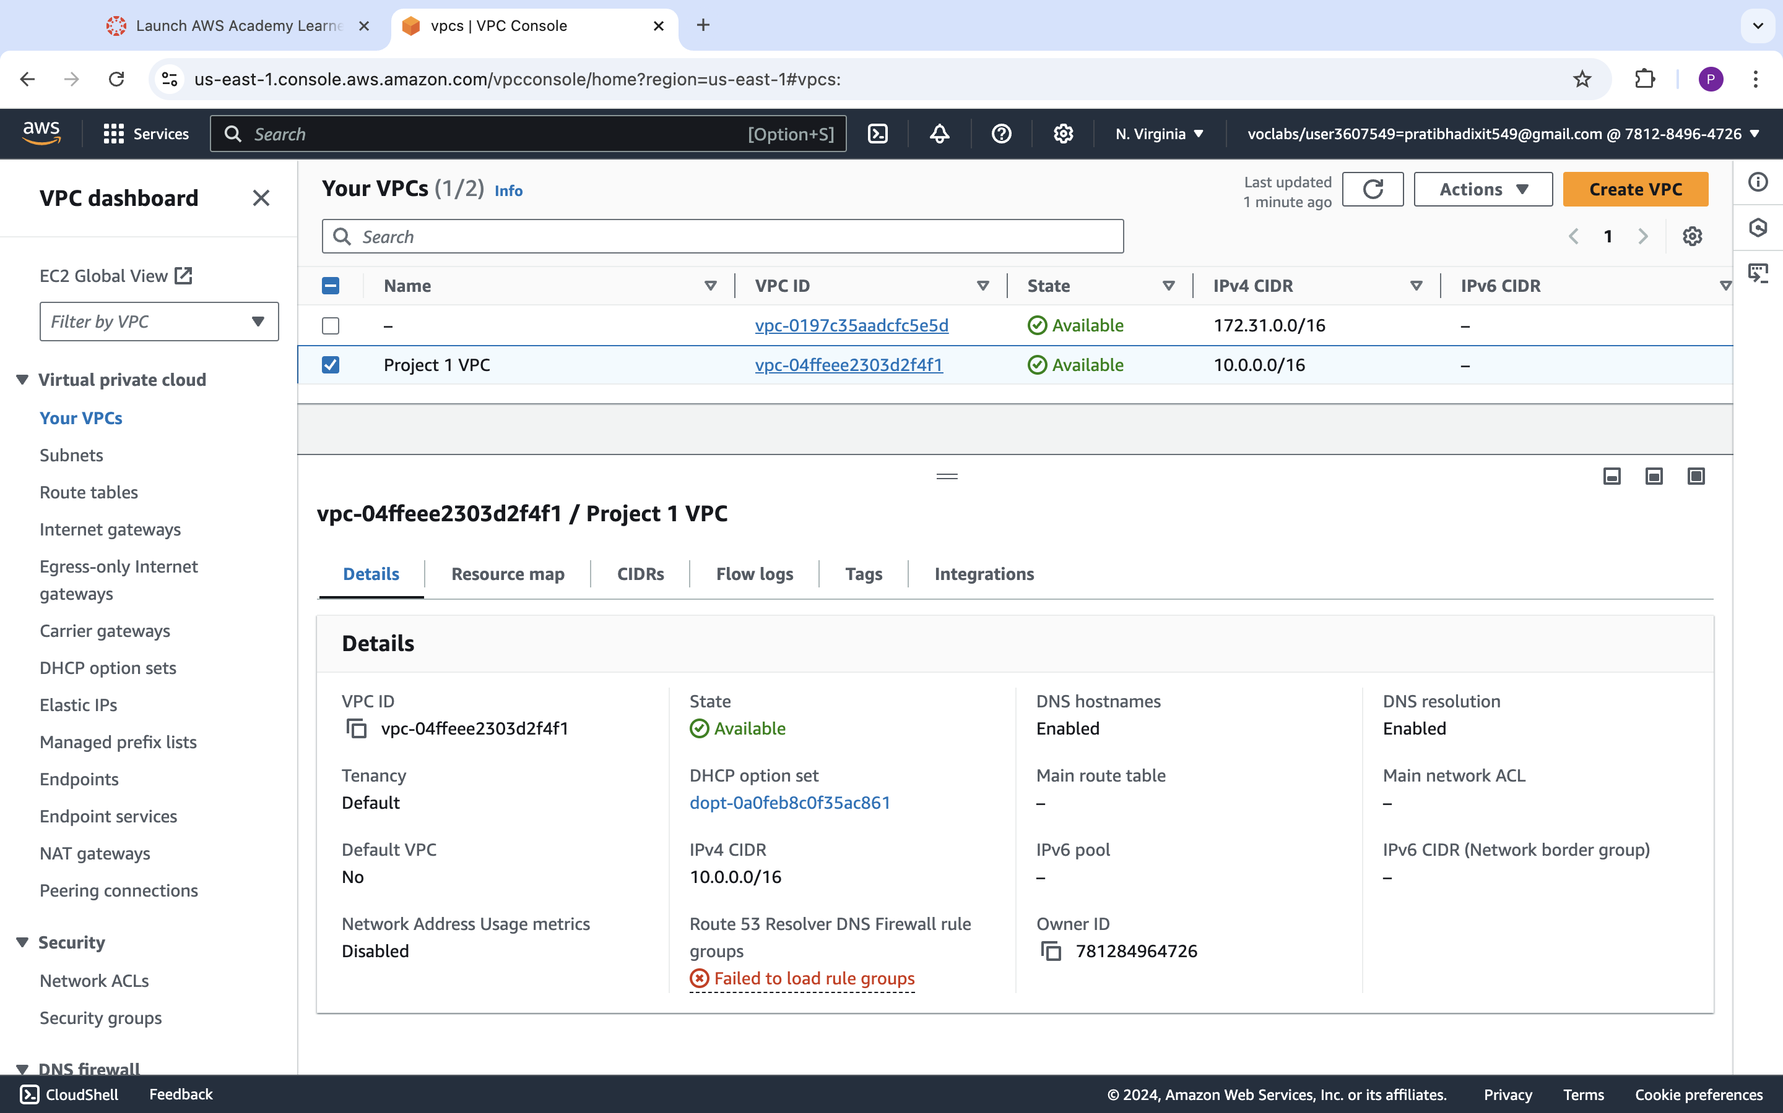

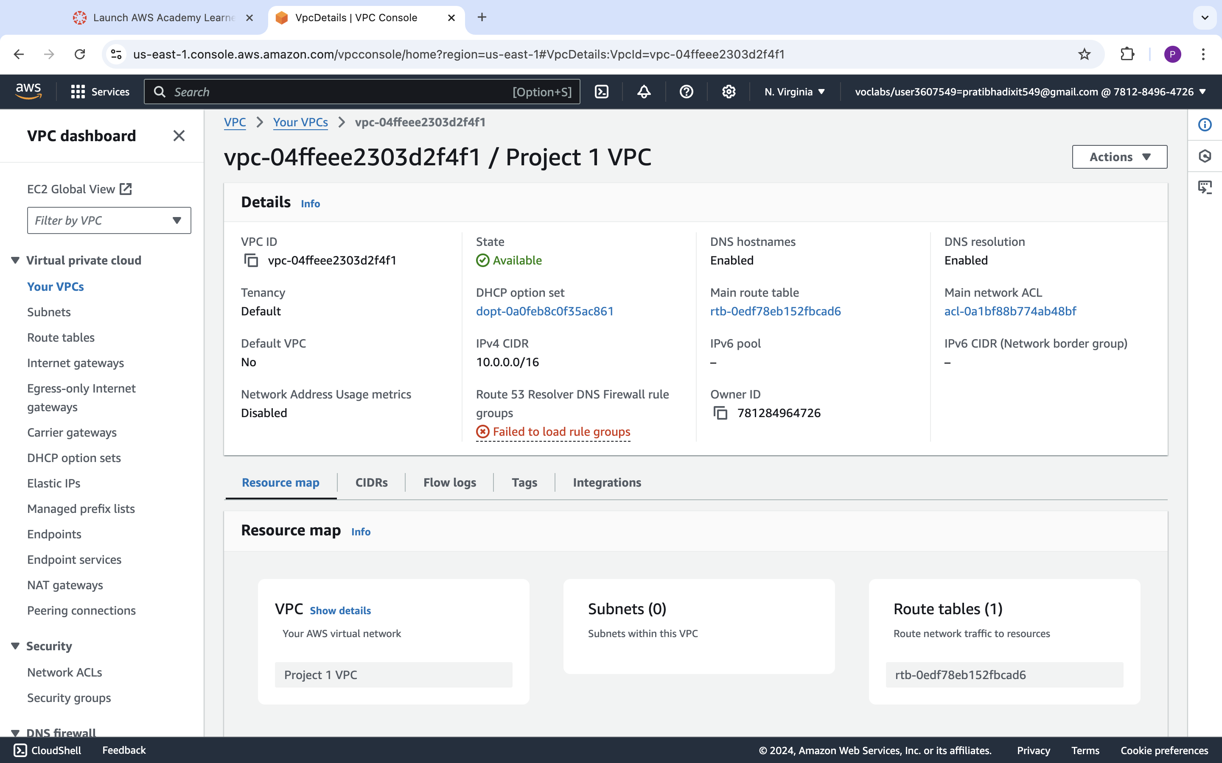

|  |  |  |
| --- | --- | --- |
| Step number | b |  |
| Step name | Creation of public subnet |  |
| Instructions | 1) Navigate to VPC->Subnets  2) Click on "Create Subnet"  3) Enter the following fields  Name tag : Public Subnet  VPC : Select the Project 1 VPC  IPv4 CIDR block : 10.0.1.0/24  The other options can be ignored  4) Click on Create  5) Once the subnet has been created, select the subnet and click on Actions->Modify Auto-assign IP settings  6) Enable the option "Auto assign IPv4" and select Save |  |
| Expected screenshots | 1. Subnet Creation screen |  |

**<Insert Screenshot b(1) here>**

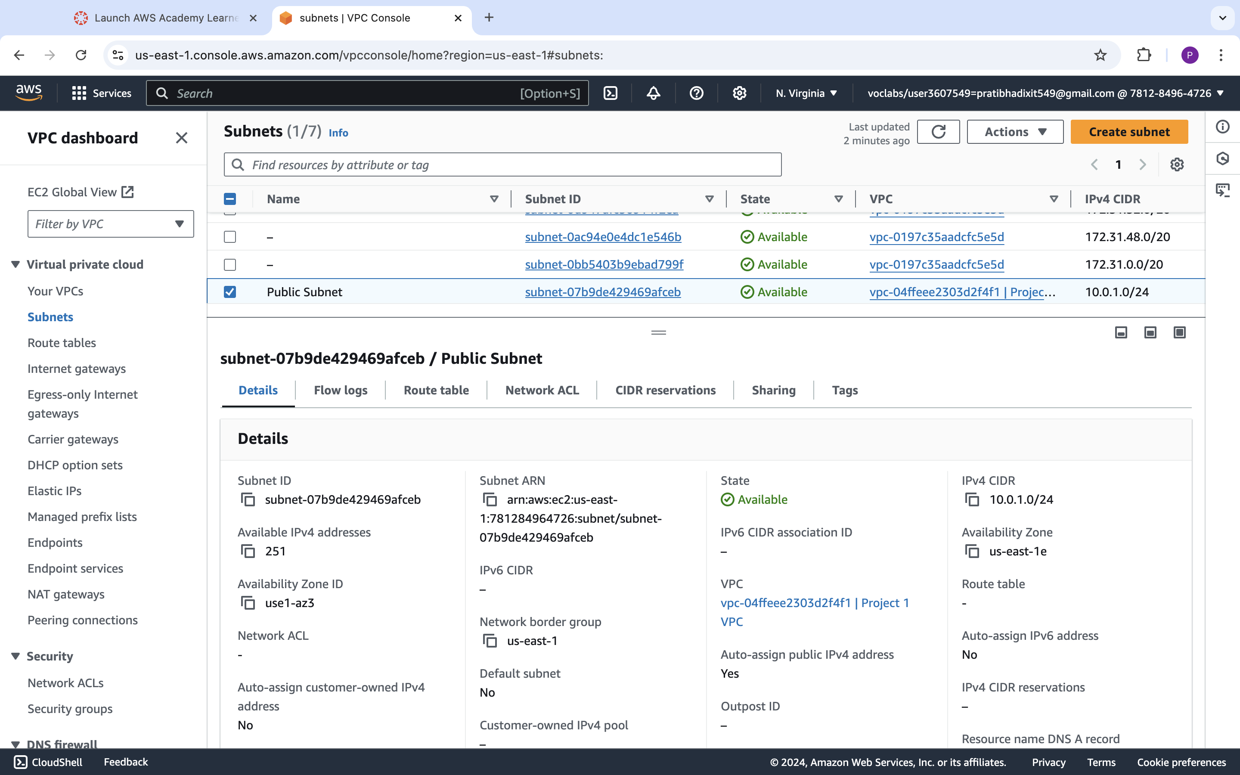

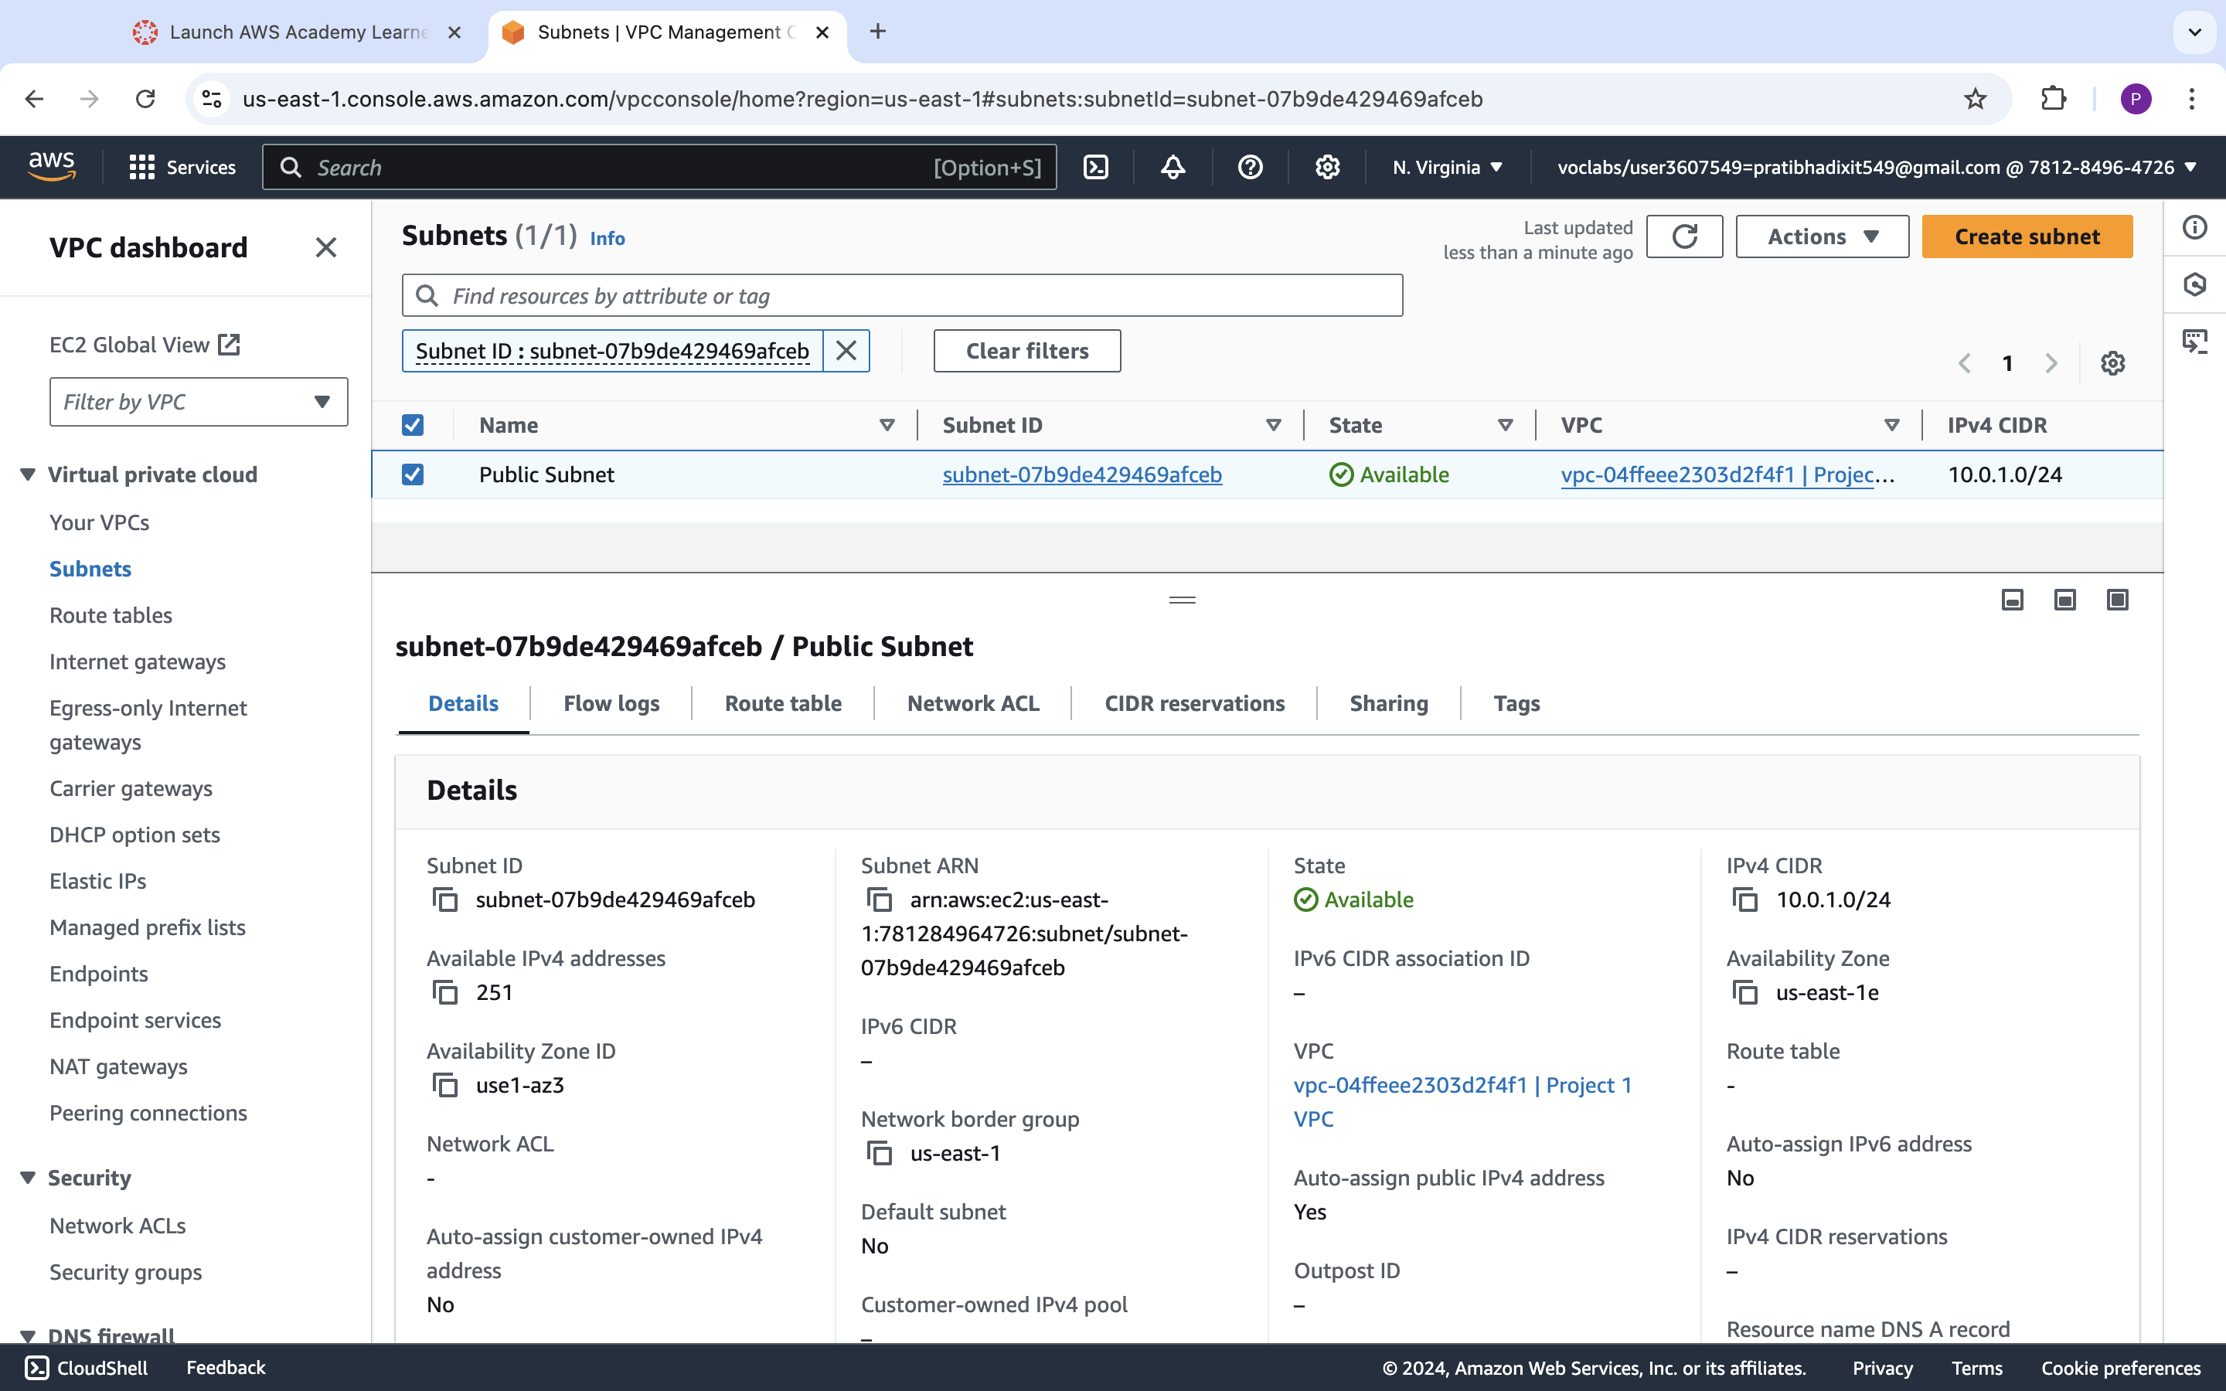

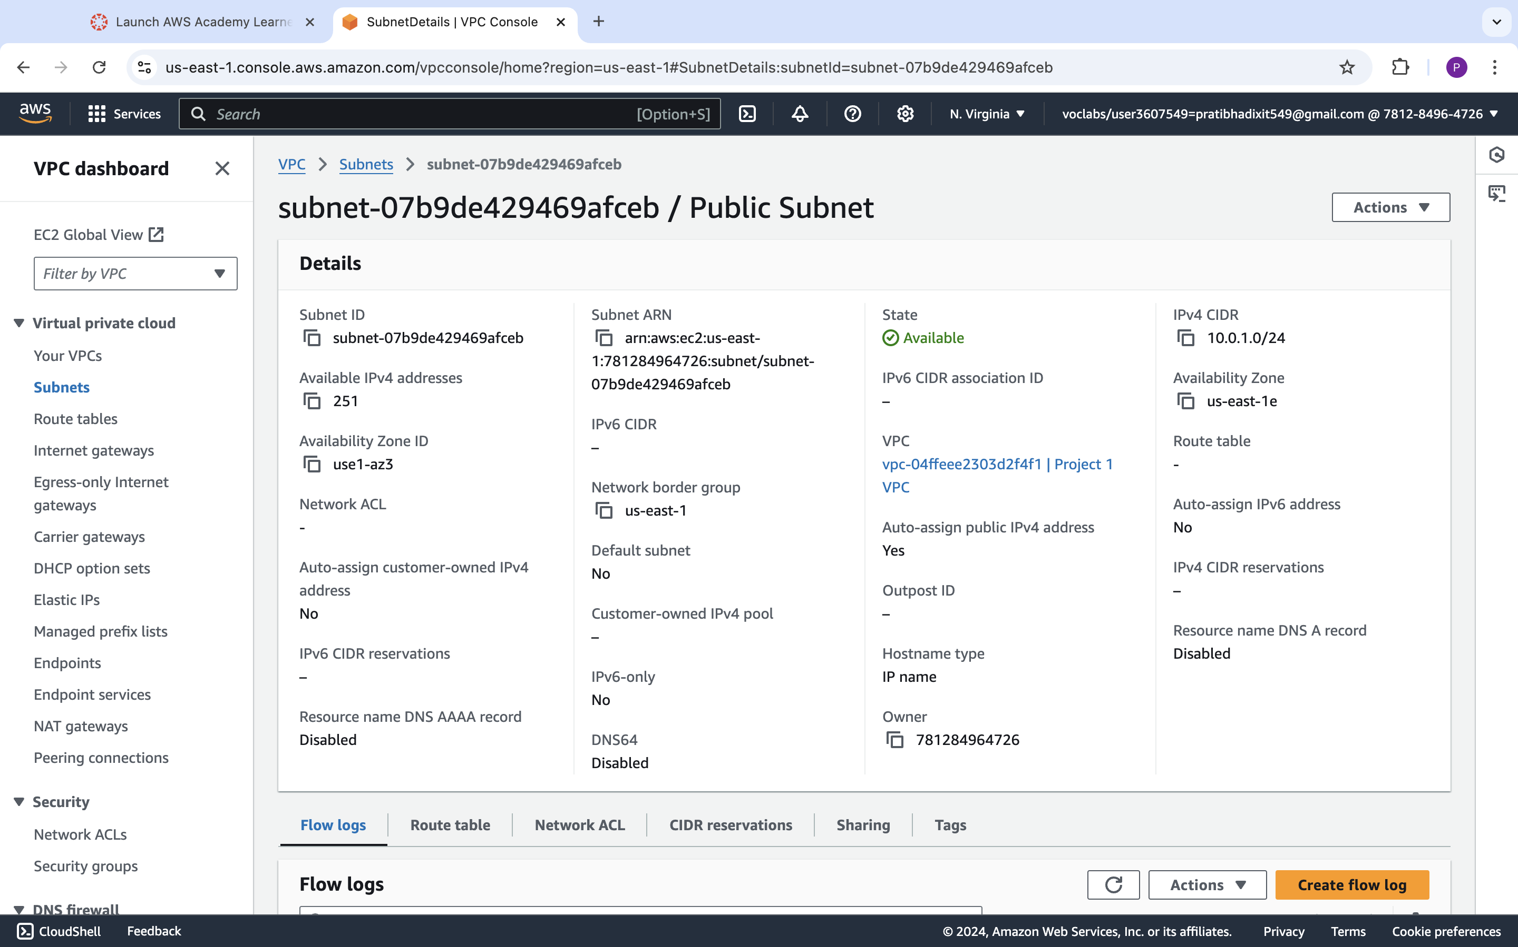

|  |  |
| --- | --- |
| Step number | C |
| Step name | Creation of private subnet |
| Instructions | 1) Navigate to VPC->Subnets  2) Click on "Create Subnet"  3) Enter the following fields  Name tag : Private Subnet  VPC : Select the Project 1 VPC  IPv4 CIDR block : 10.0.2.0/24  The other options can be ignored  4) Click on Create |
| Expected screenshots | 1. Subnet Creation screen |

**<Insert Screenshot c(1) here>**

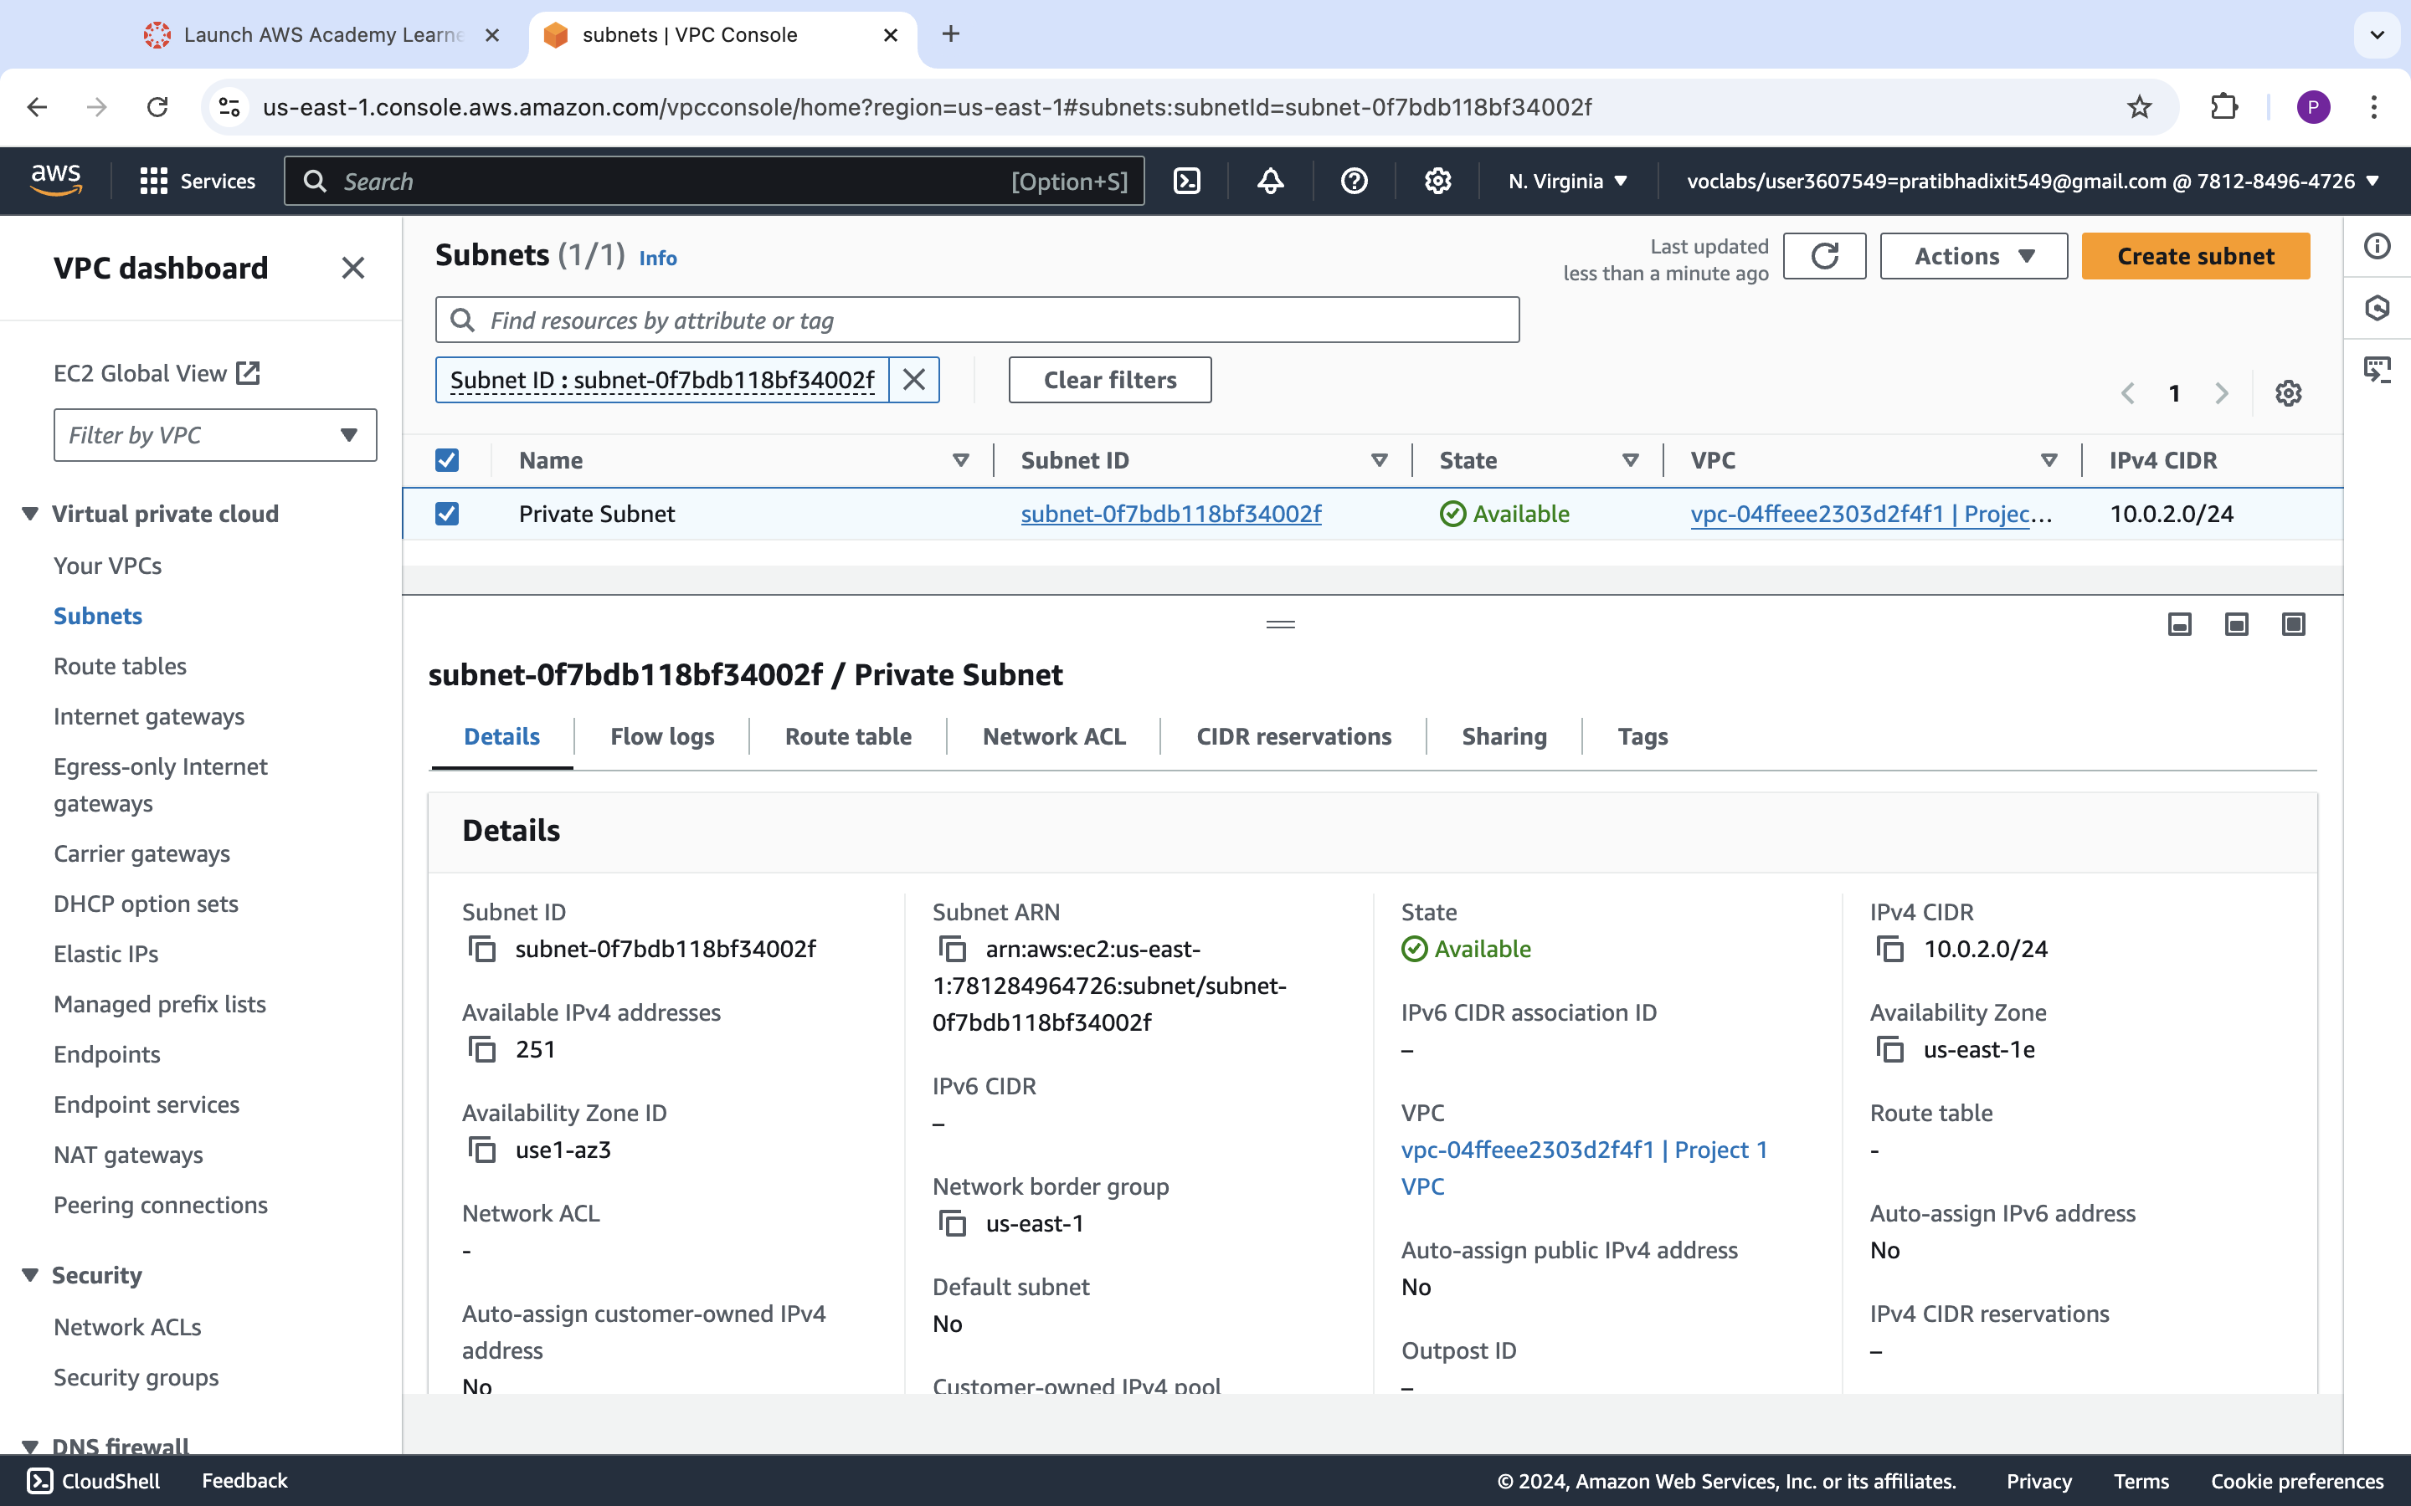

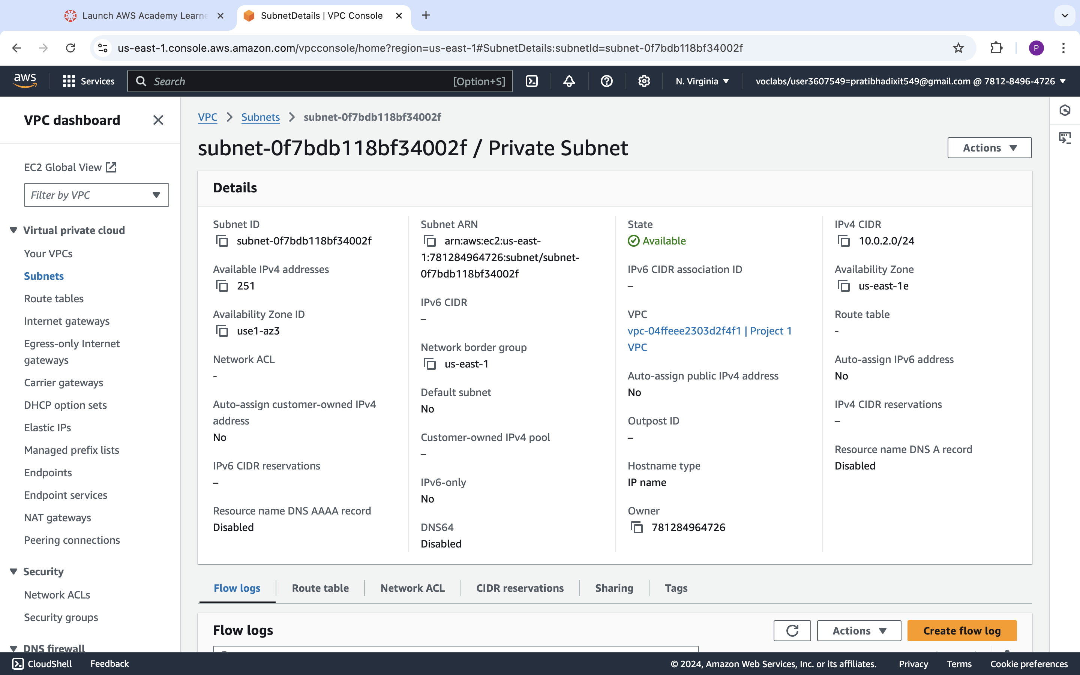

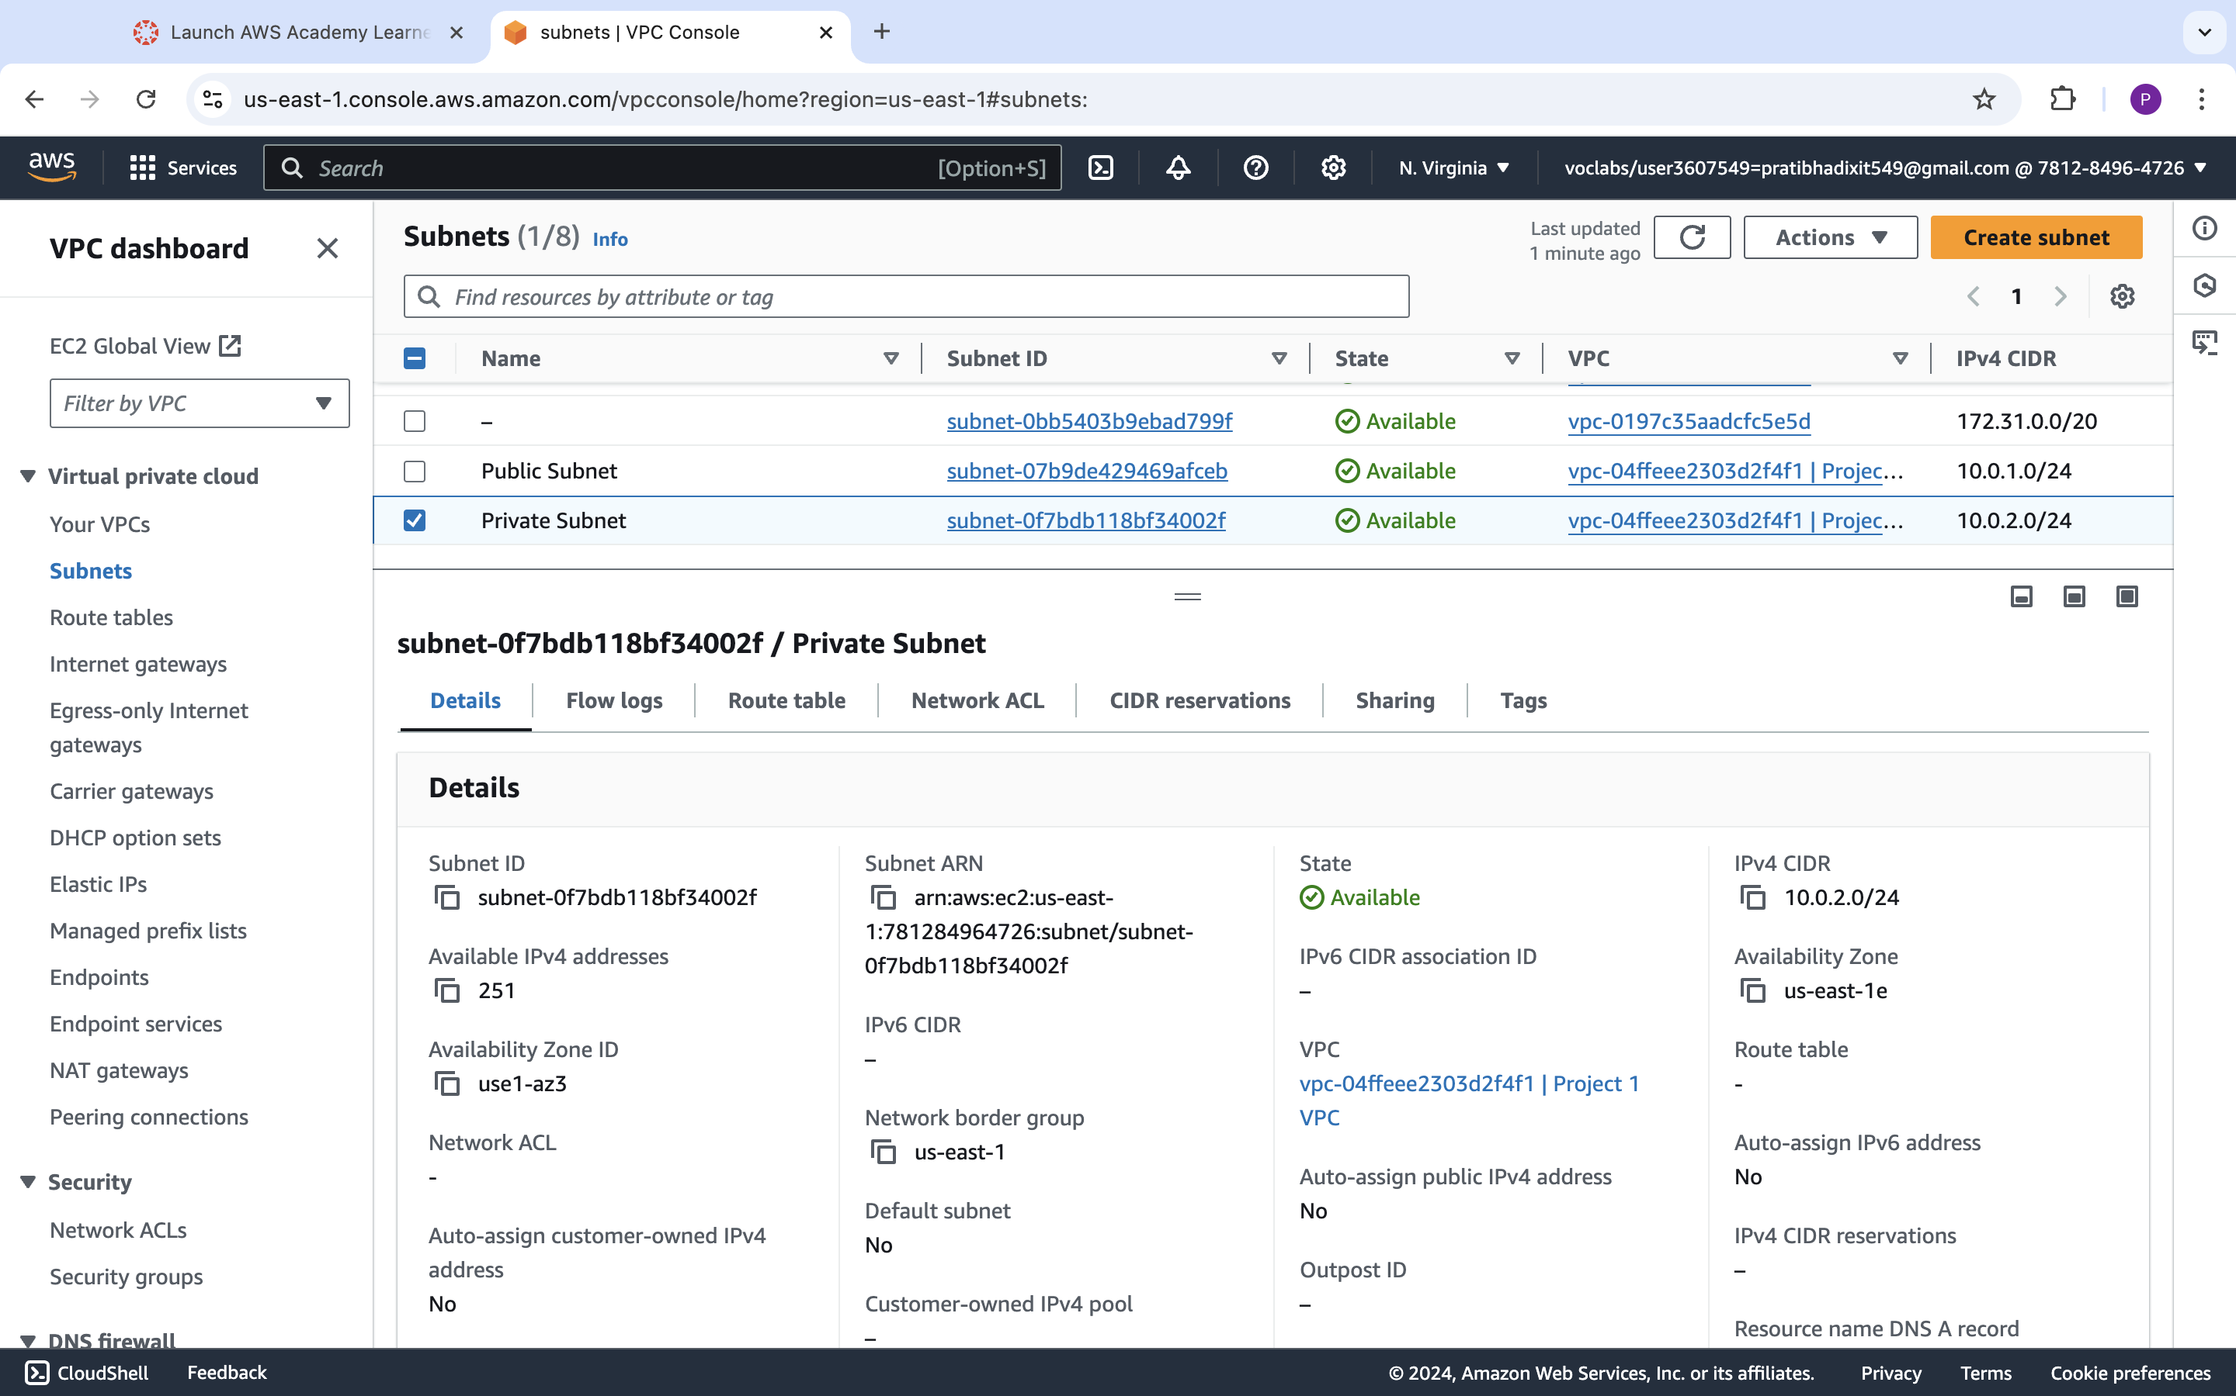

**Step 2 : Internet Gateway and VPC**

|  |  |  |
| --- | --- | --- |
| Step number | a |  |
| Step name | Creation and Configuration of Internet Gateway |  |
| Instructions | 1) Navigate to VPCs->Internet Gateway  2) Click on "Create Internet Gateway"  3) Enter the name tag "Project 1 Internet Gateway" and click on "Create Internet Gateway"  4) After the gateway is created, select it and click on Actions->Attach to VPC  5) Select the Project 1 VPC and click on "Attach Internet Gateway" |  |
| Expected screenshots | 1. Creation of Internet Gateway |  |

**<Insert Screenshot a(1) here >**

**Internet Gateway Creation before VPC attached Screenshot:**

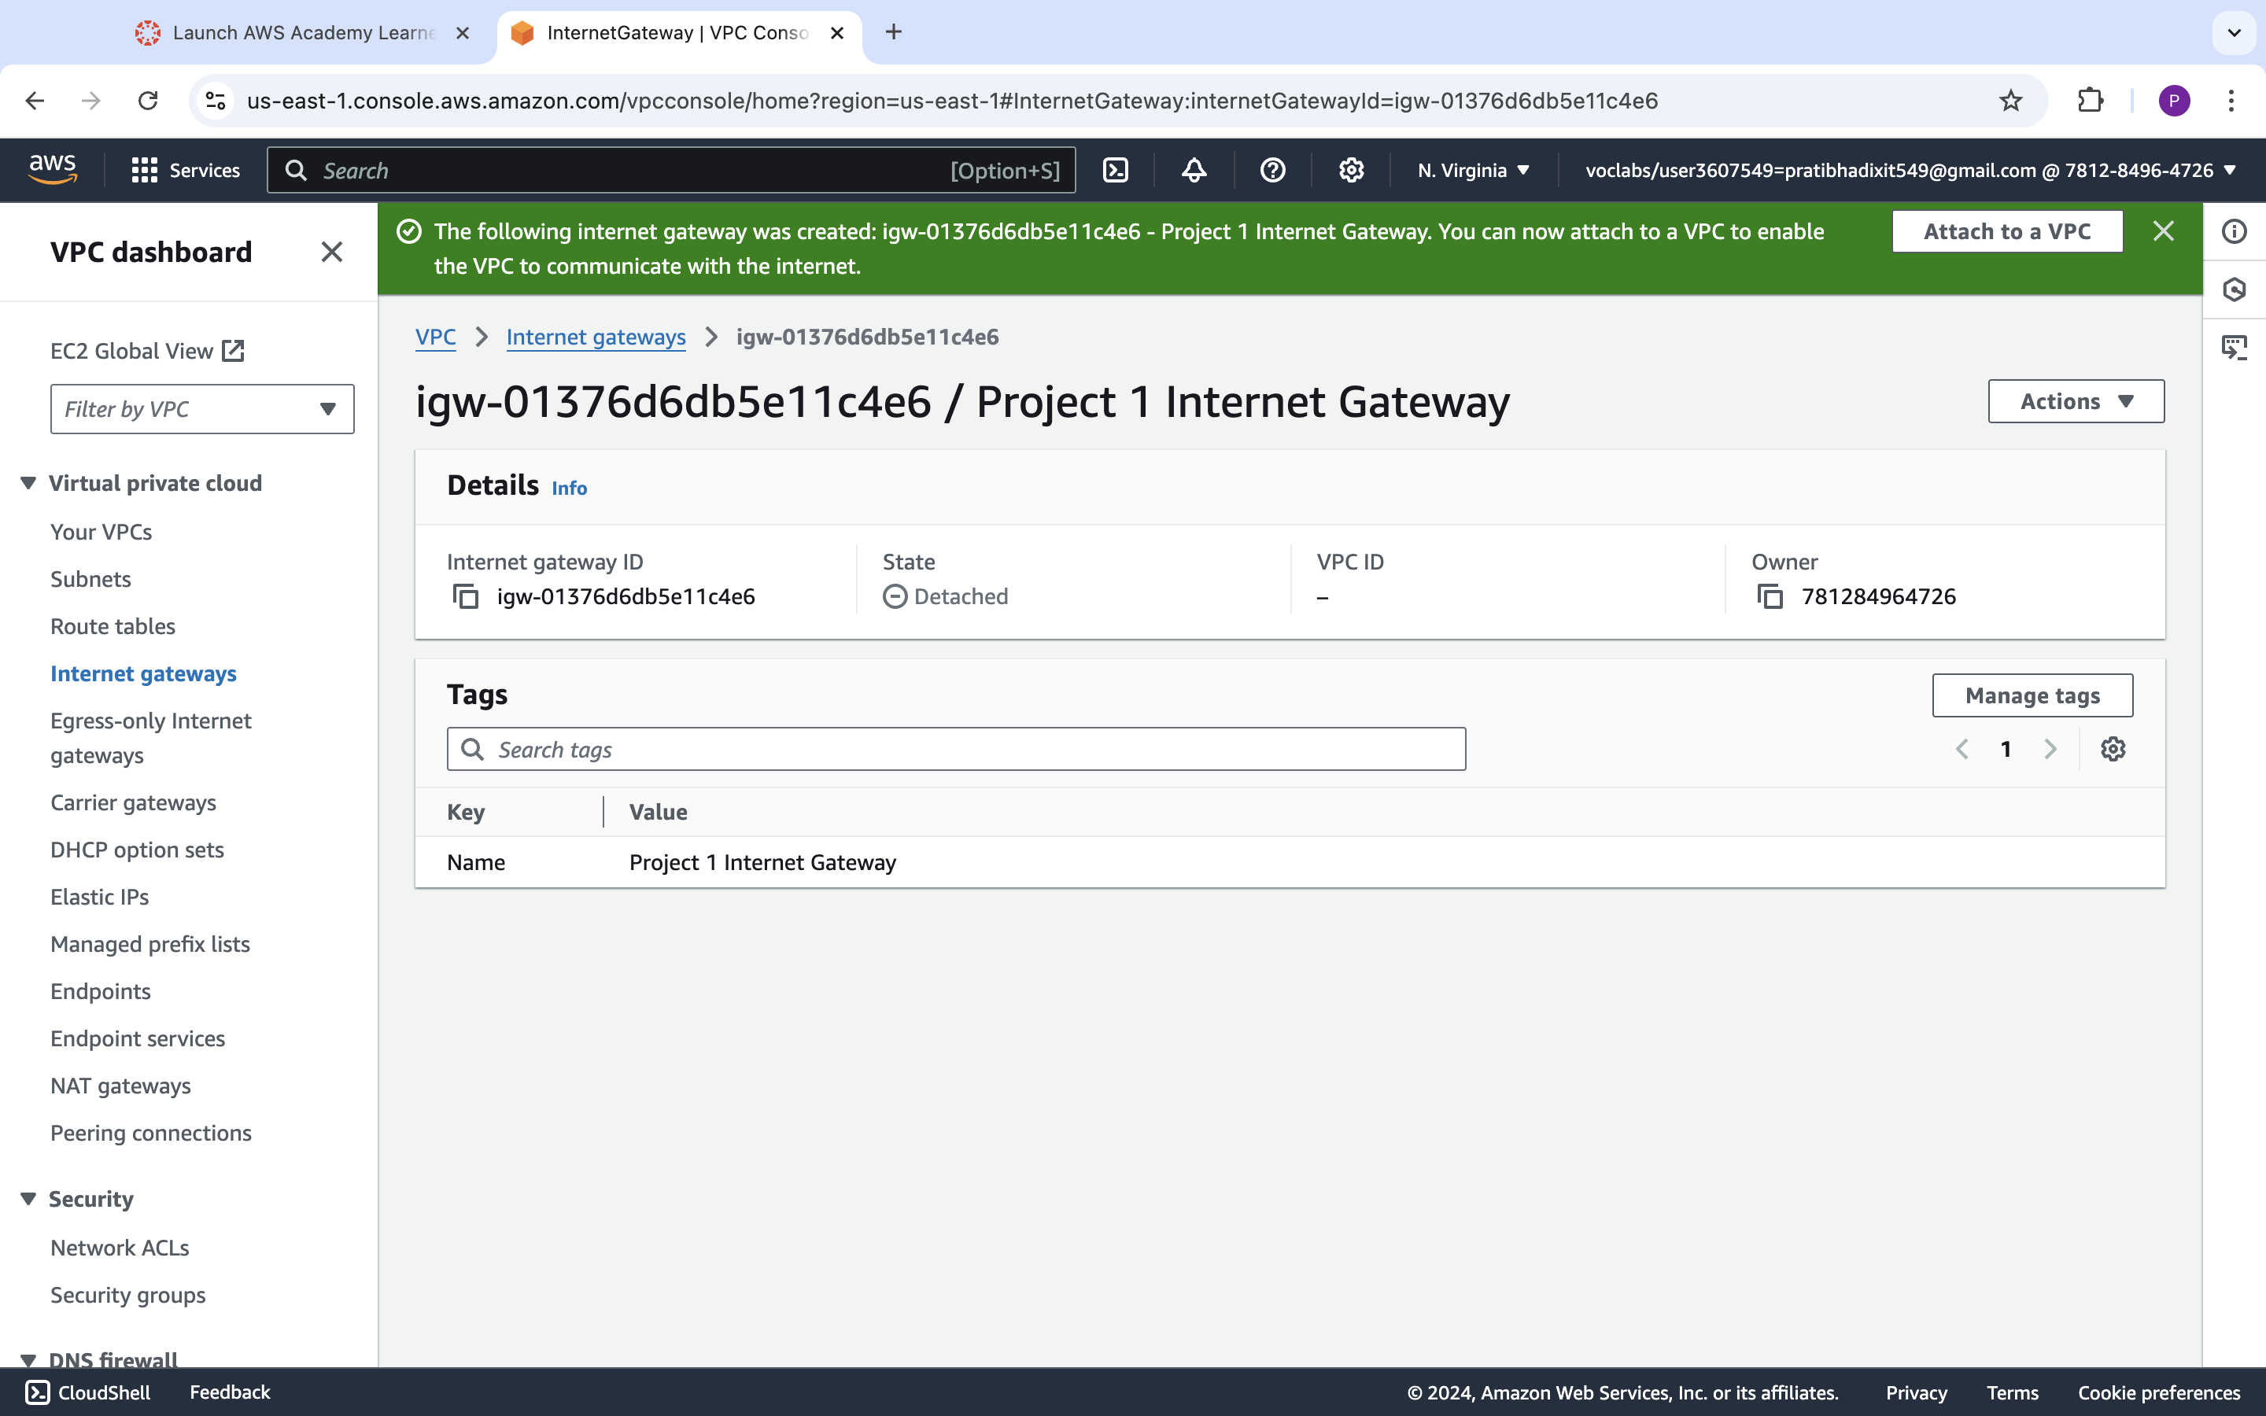

**Internet Gateway Creation Screenshot after VPC attached:**

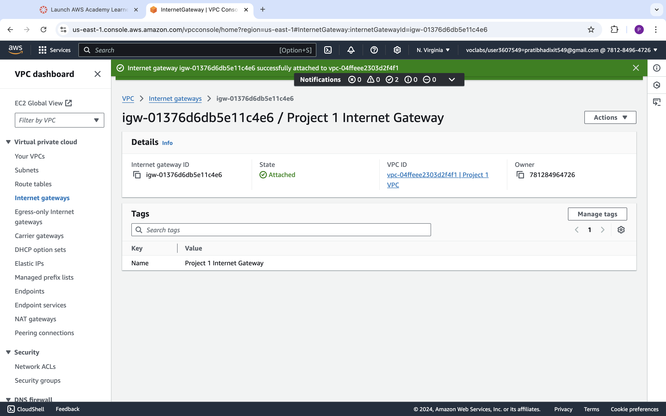

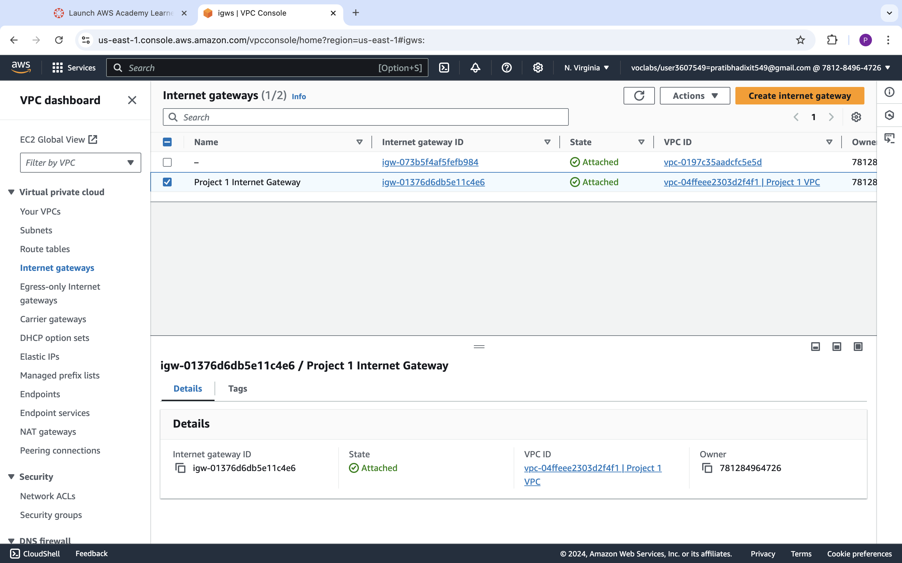

|  |  |  |
| --- | --- | --- |
| Step number | b |  |
| Step name | Creation of public route table |  |
| Instructions | 1) Navigate to VPC -> Route Tables and click on Create Route table  2) Enter the name tag "Public Route Table", select the Project 1 VPC from the dropdown and click on Create  3) Once the route table is created, select it and select the Routes tab below the list of route tables  4) Click in Edit Routes and add the following route (Don't edit the existing one)  - Destination : 0.0.0.0/0  - Target : Select Internet Gateway and the select the Project 1 Internet Gateway  Click on Save Routes  5) Select the Subnet Associations tab and click on Edit Subnet Associations  6) Select the Public Subnet from the list and click on Save |  |
| Expected screenshots | 1. Route list of the route table 2. Subnet Associations of the route table |  |

**<Insert Screenshot b(1) here>**

**Screenshot before editing Routes:**

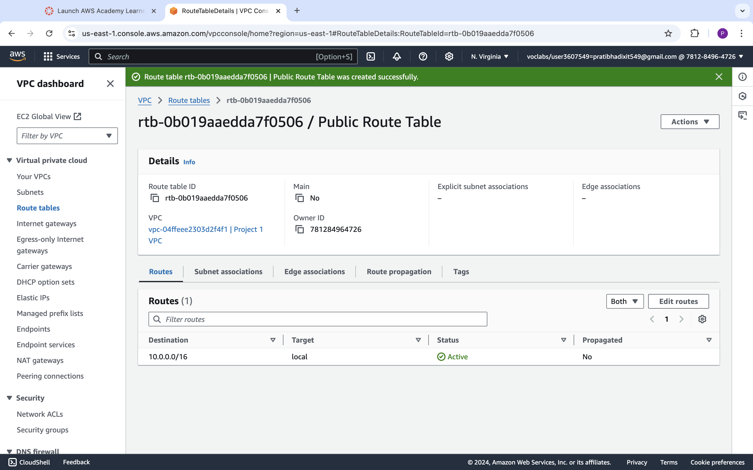

**Screenshot after editing Routes:**

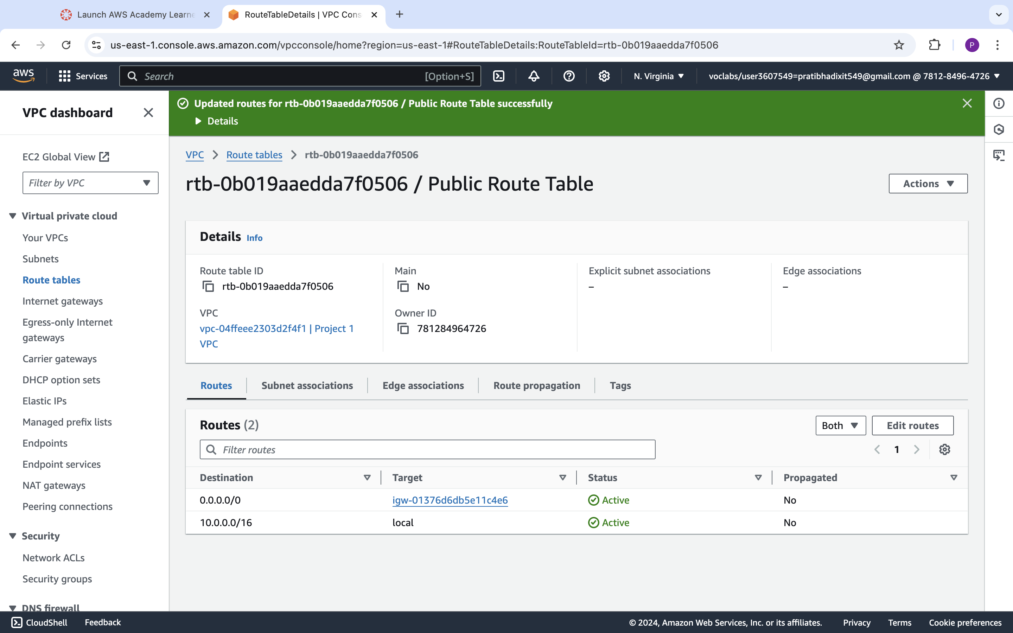

**<Insert Screenshot b(2) here>**

**Screenshot before editing Subnet :**

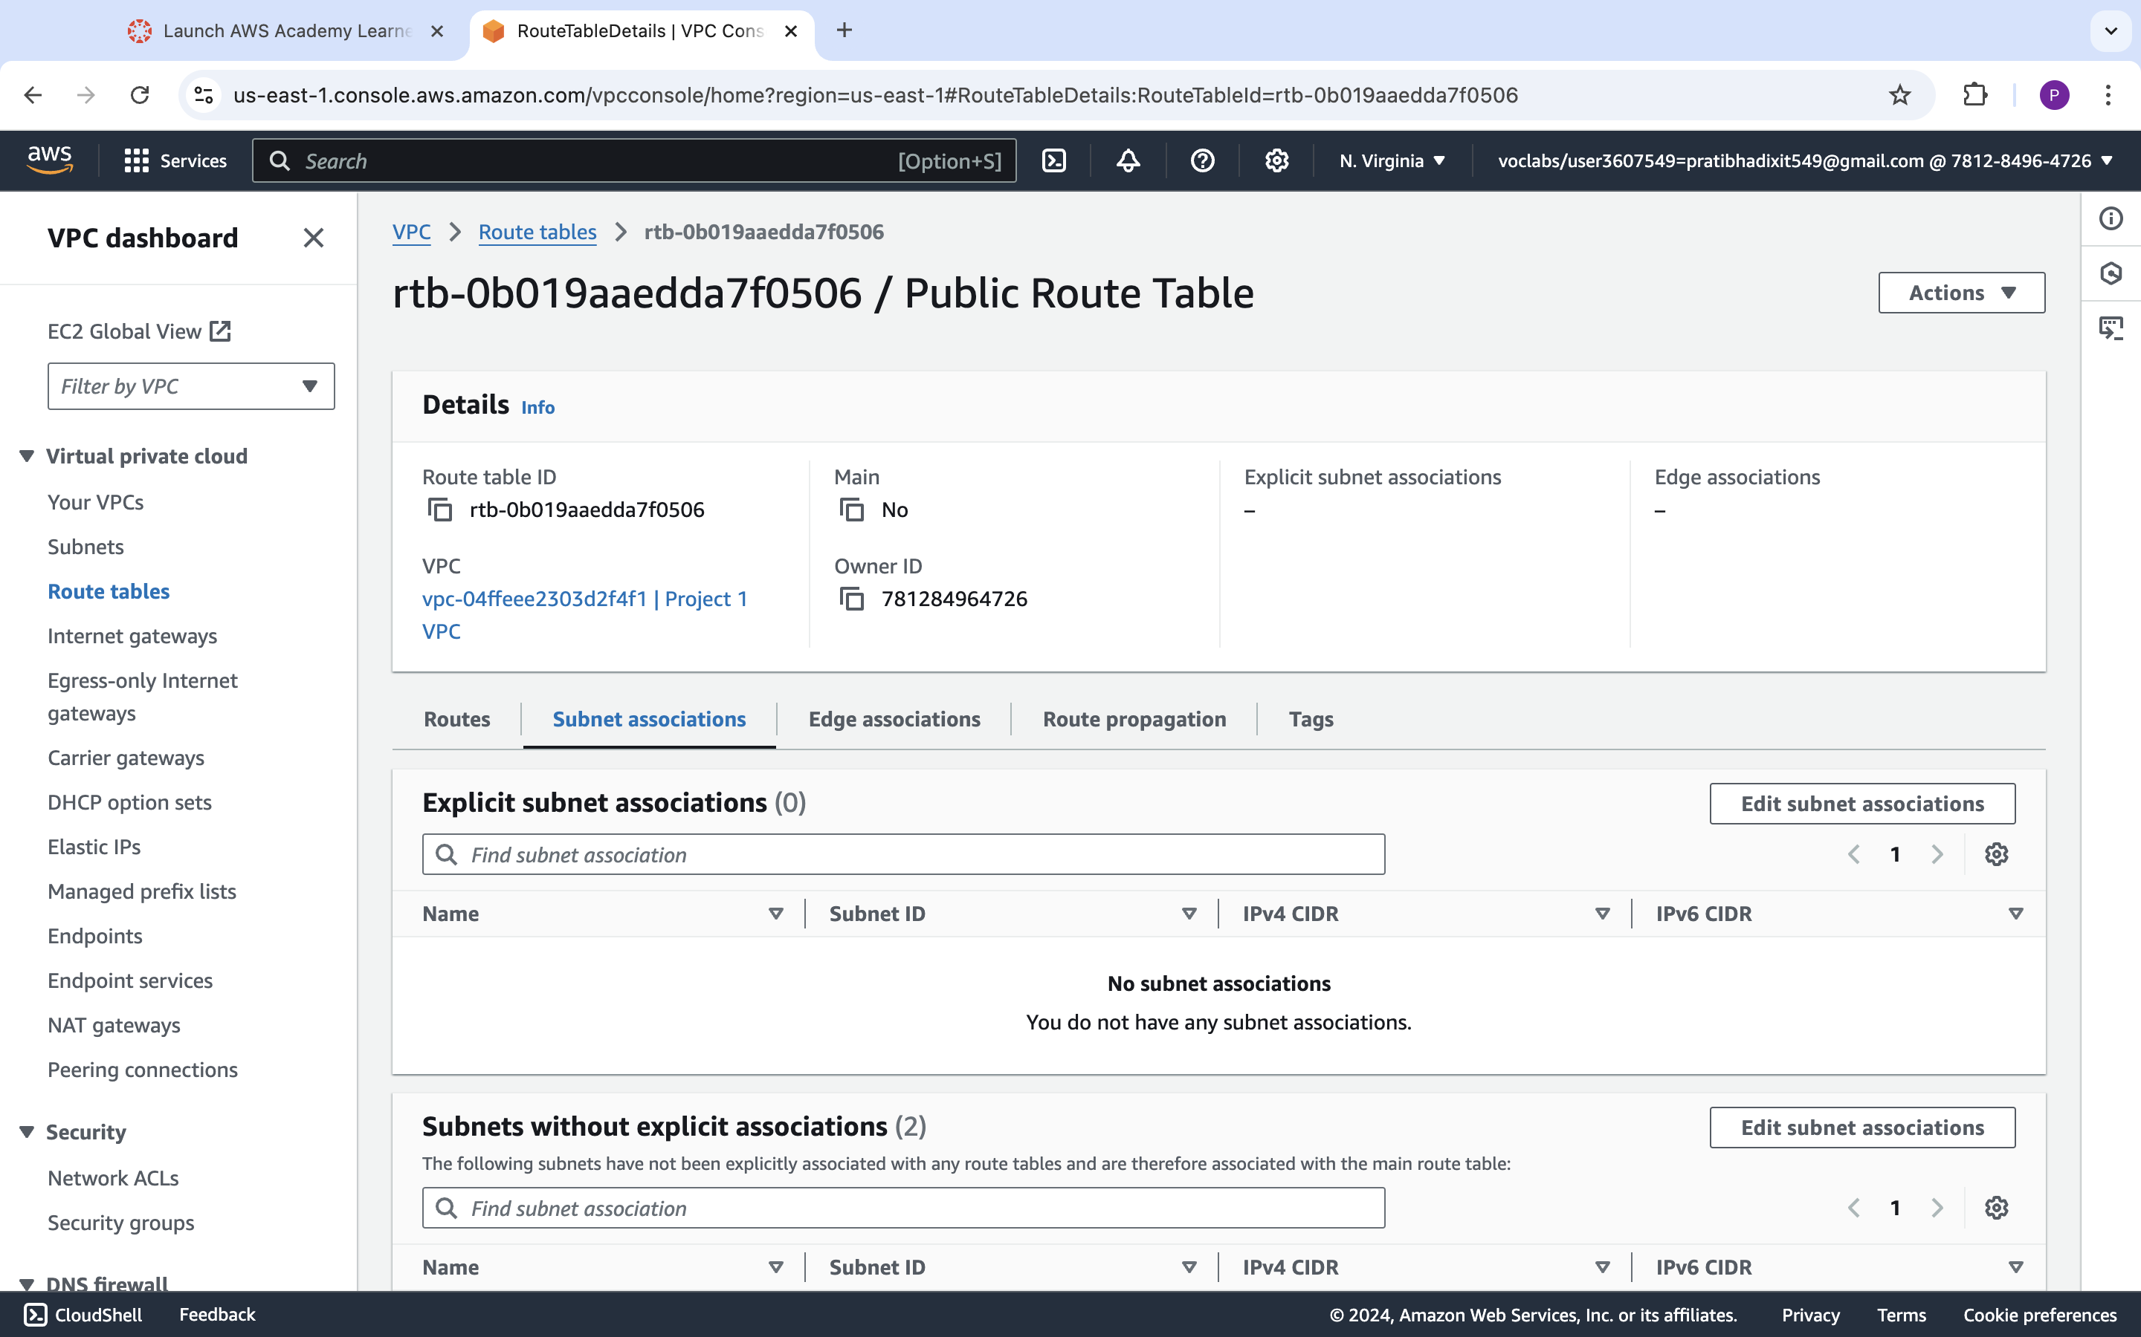

**Screenshot after editing Subnet :**

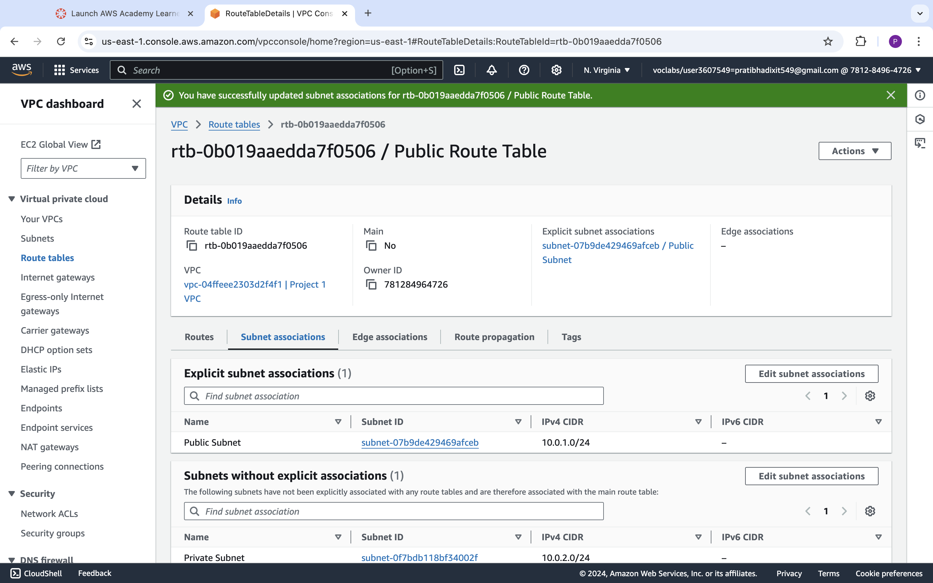

|  |  |  |  |  |
| --- | --- | --- | --- | --- |
| Step number | c |  |  |  |
| Step name | Creation of NAT gateway |  |  |  |
| Instructions | 1) Navigate to VPC using the Services button at the top of the screen  2) Select NAT Gateway at the left side of the screen  3) Click on Create NAT Gateway  - Deploy it in the public subnet  - Connectivity type : Public  - Allocate an elastic IP by clicking on “Allocate Elastic IP”  4) Click on “Create NAT Gateway” to create the gateway |  |  |  |
| Expected screenshots | 1. NAT gateway creation details 2. Gateway after creation |  |  |  |
|  |  |  |  |  |

**<Insert Screenshot c(1) here>**

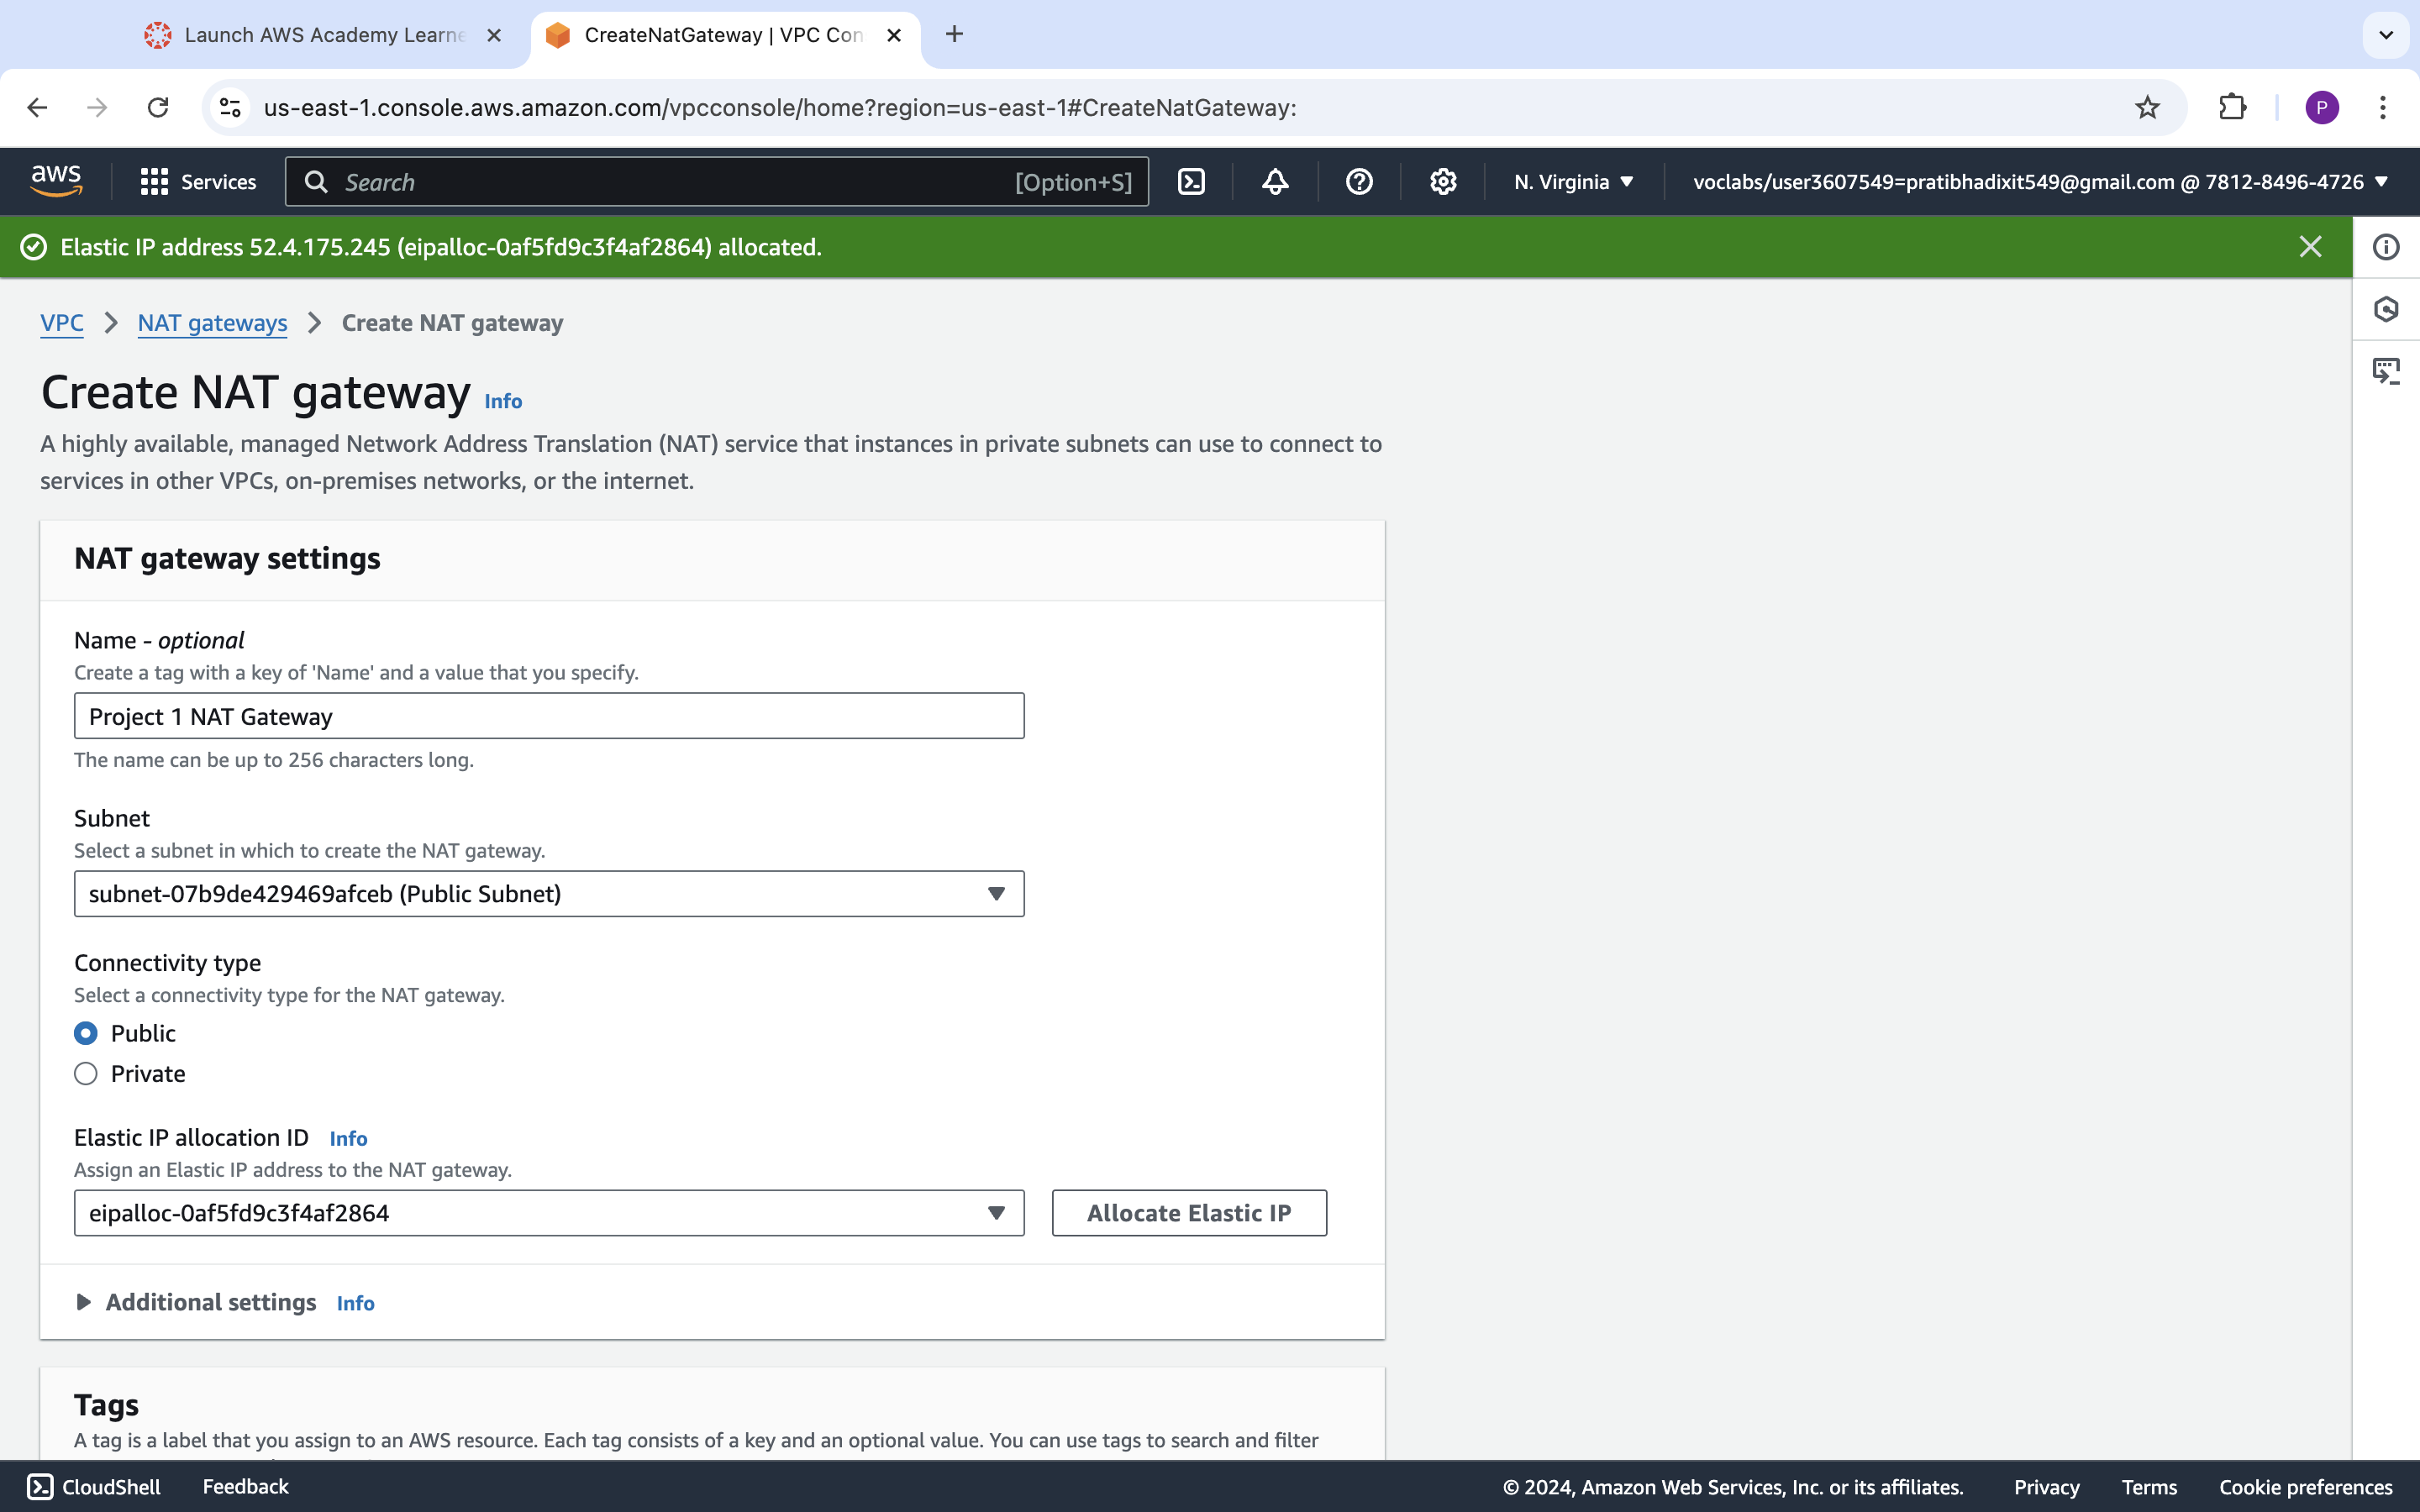

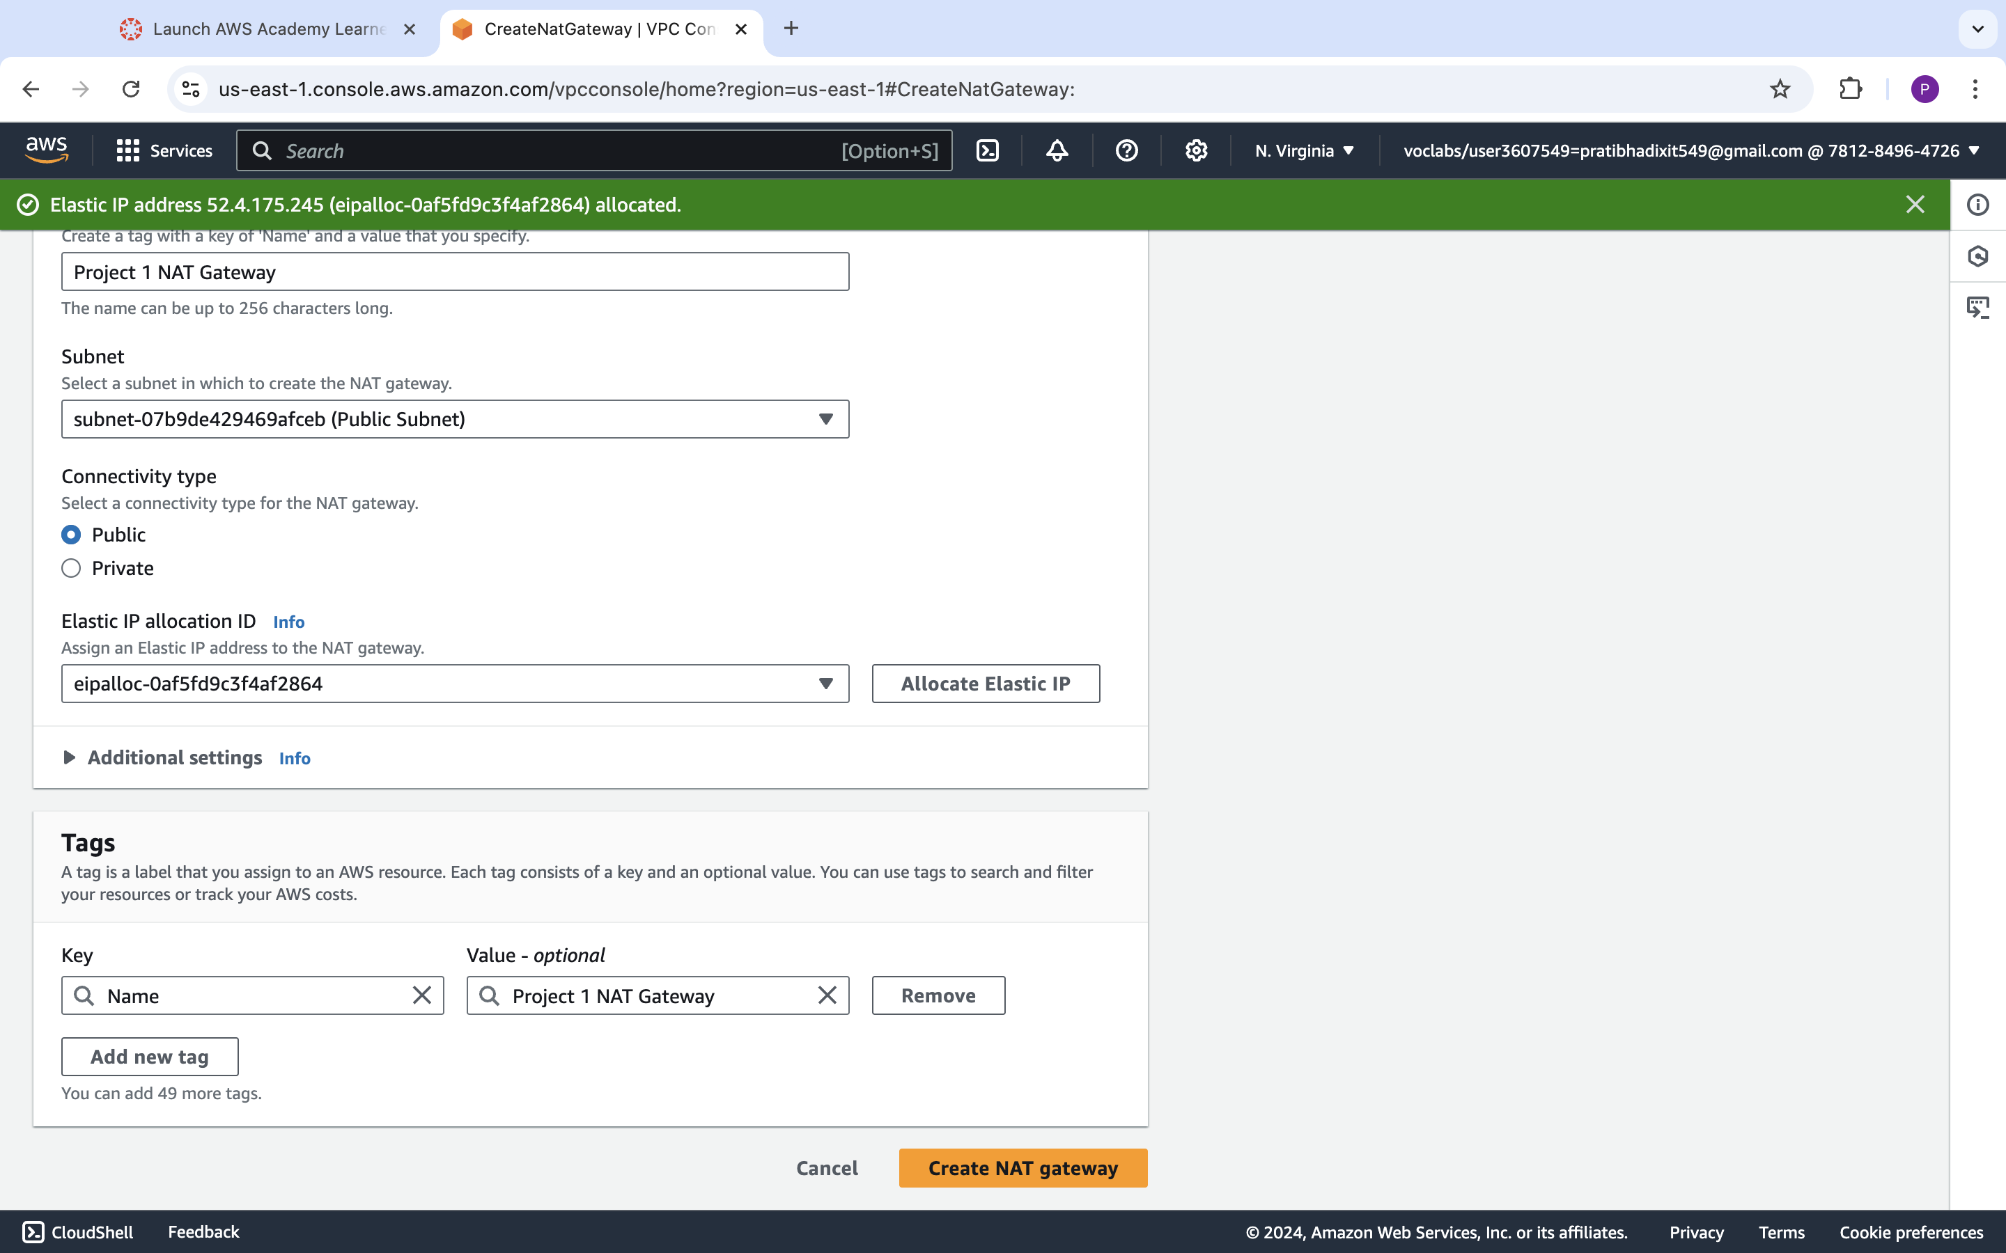

**<Insert Screenshot c(2) here>**

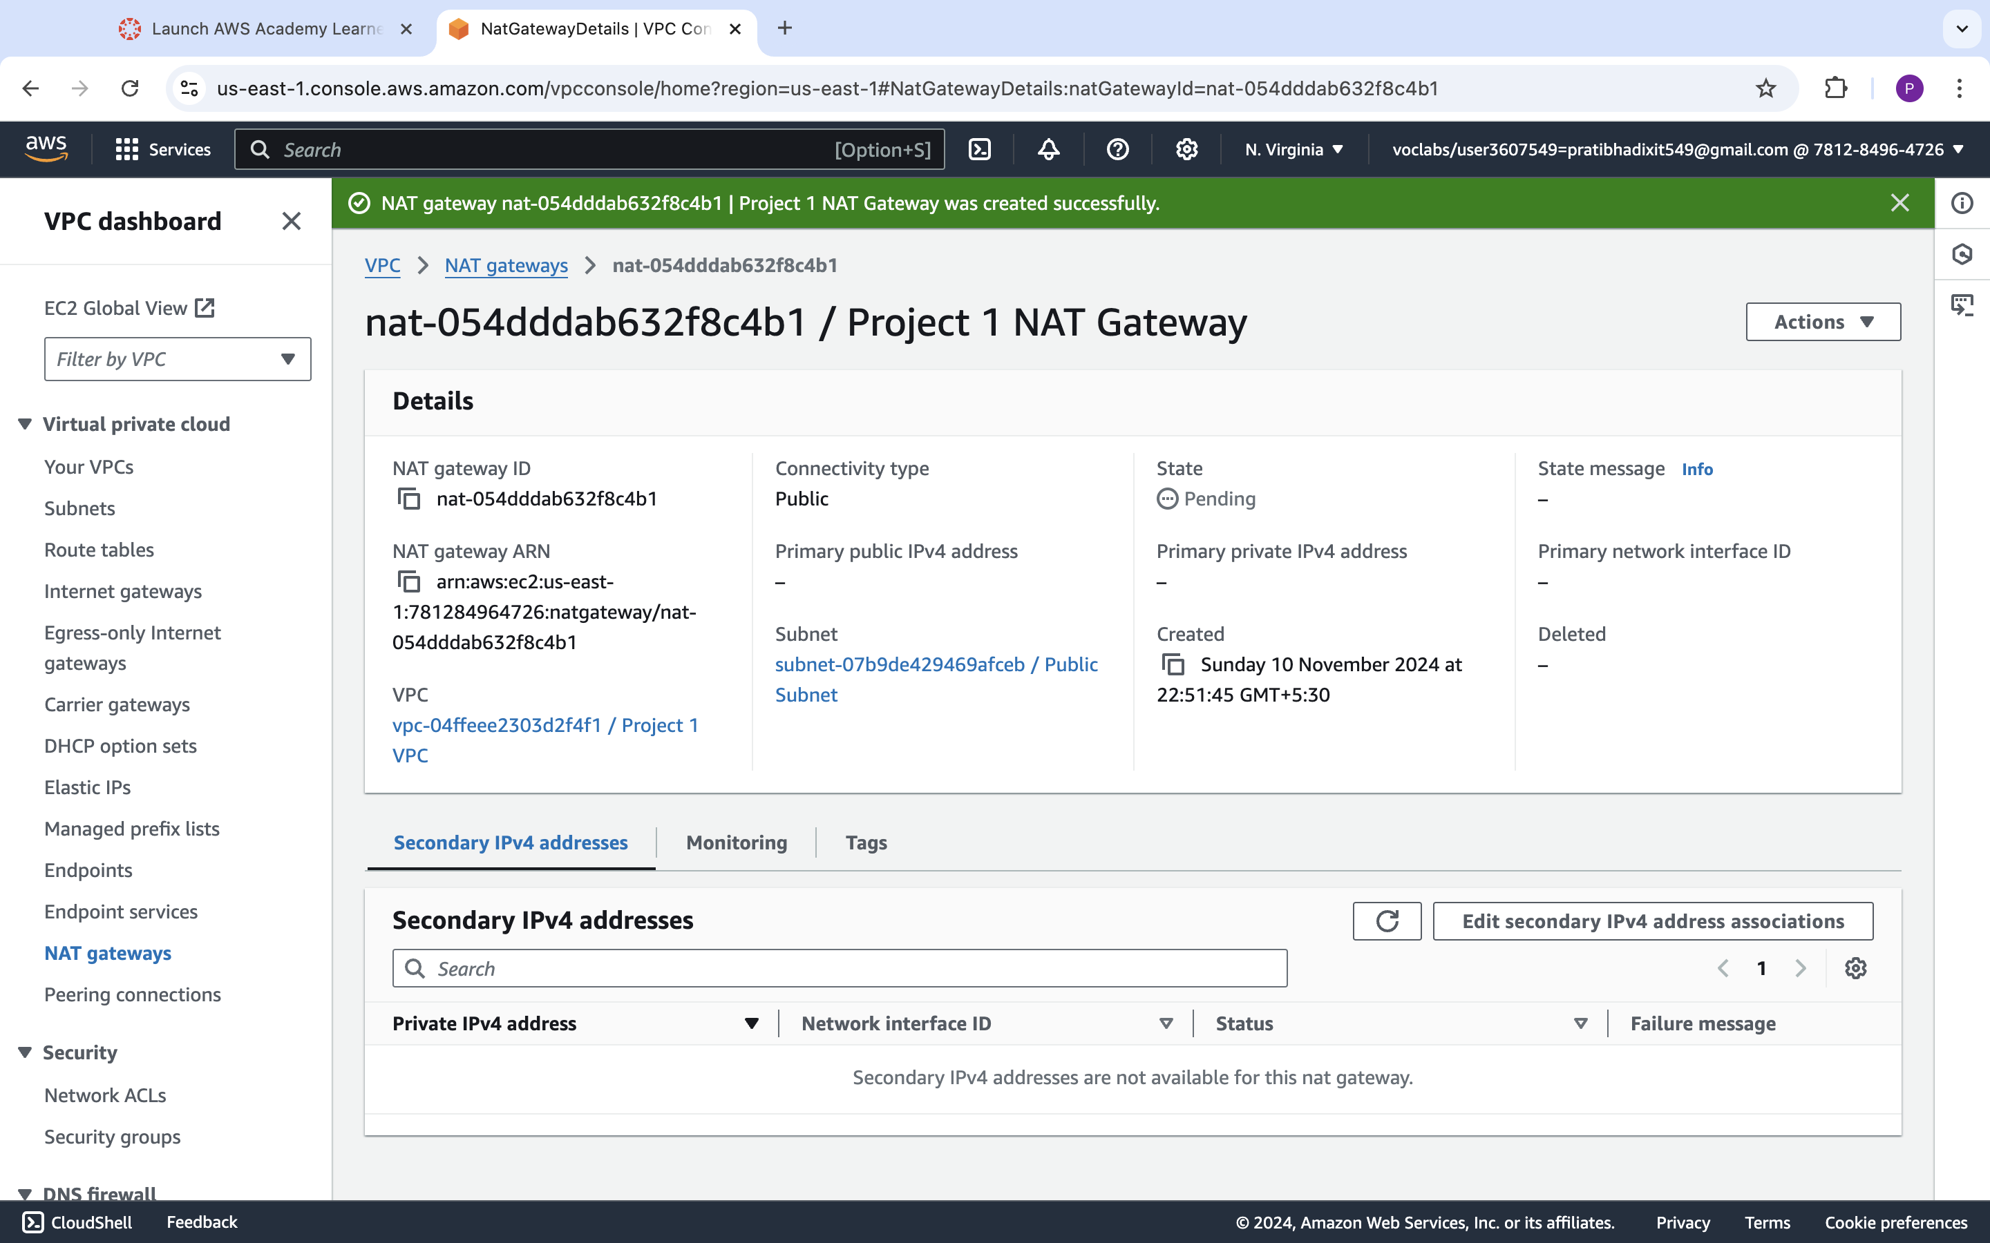

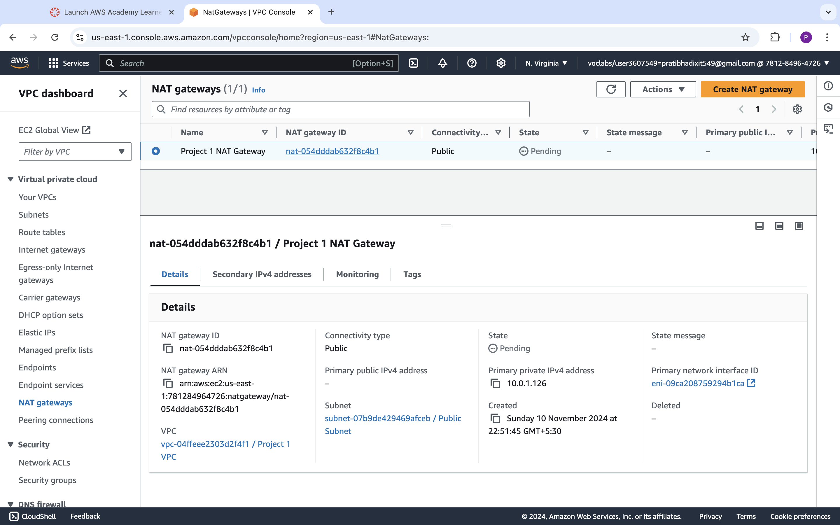

|  |  |  |  |  |
| --- | --- | --- | --- | --- |
| Step number | d |  |  |  |
| Step name | Creation of private route tables |  |  |  |
| Instructions | 1) Navigate to VPC -> Route Tables and click on Create Route table  2) Enter the name tag "Private Route Table", select the Project 1 VPC from the dropdown and click on Create  3) Once the route table is created, select it and select the Routes tab below the list of route tables  4) Click in Edit Routes and add the following route (Don't edit the existing one)  - Destination : 0.0.0.0/0  - Target: Select NAT Gateway and select the NAT Gateway created in the previous step  Click on Save Routes  5) Select the Subnet Associations tab and click on Edit Subnet Associations  6) Select the private Subnet from the list and click on Save |  |  |  |
| Expected screenshots | 1. Route list of the route table 2. Subnet association of the route table |  |  |  |

**<Insert Screenshot for d(1) here >**

**Screenshot before editing Routes:**

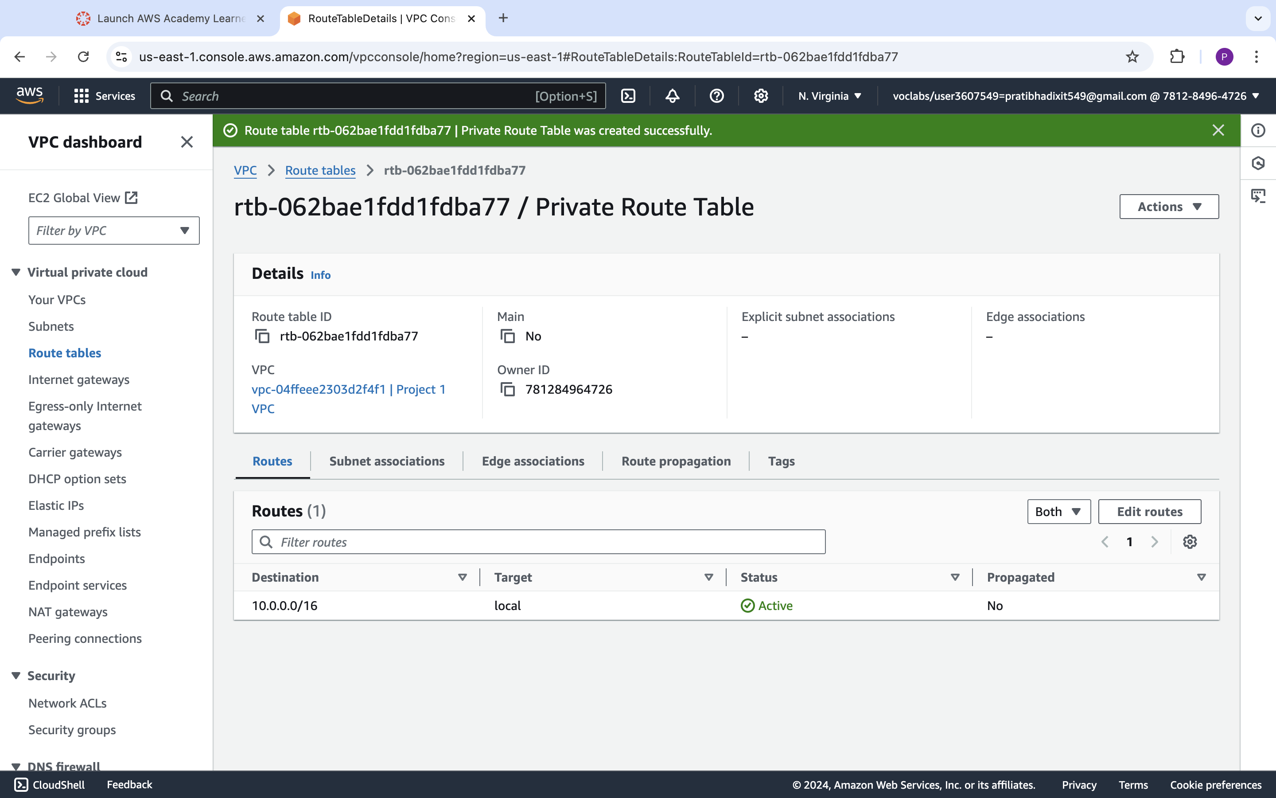

**Screenshot after editing Routes:**

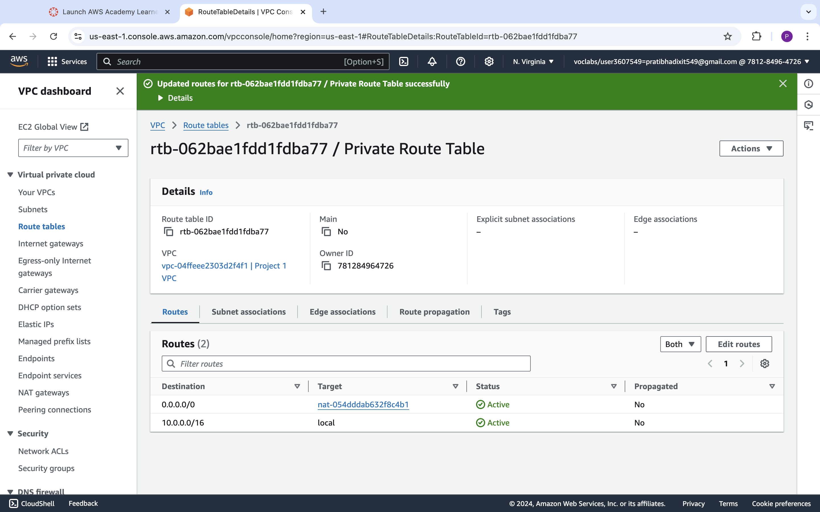

**<Insert Screenshot for d(2) here>**

**Screenshot before editing Subnet :**

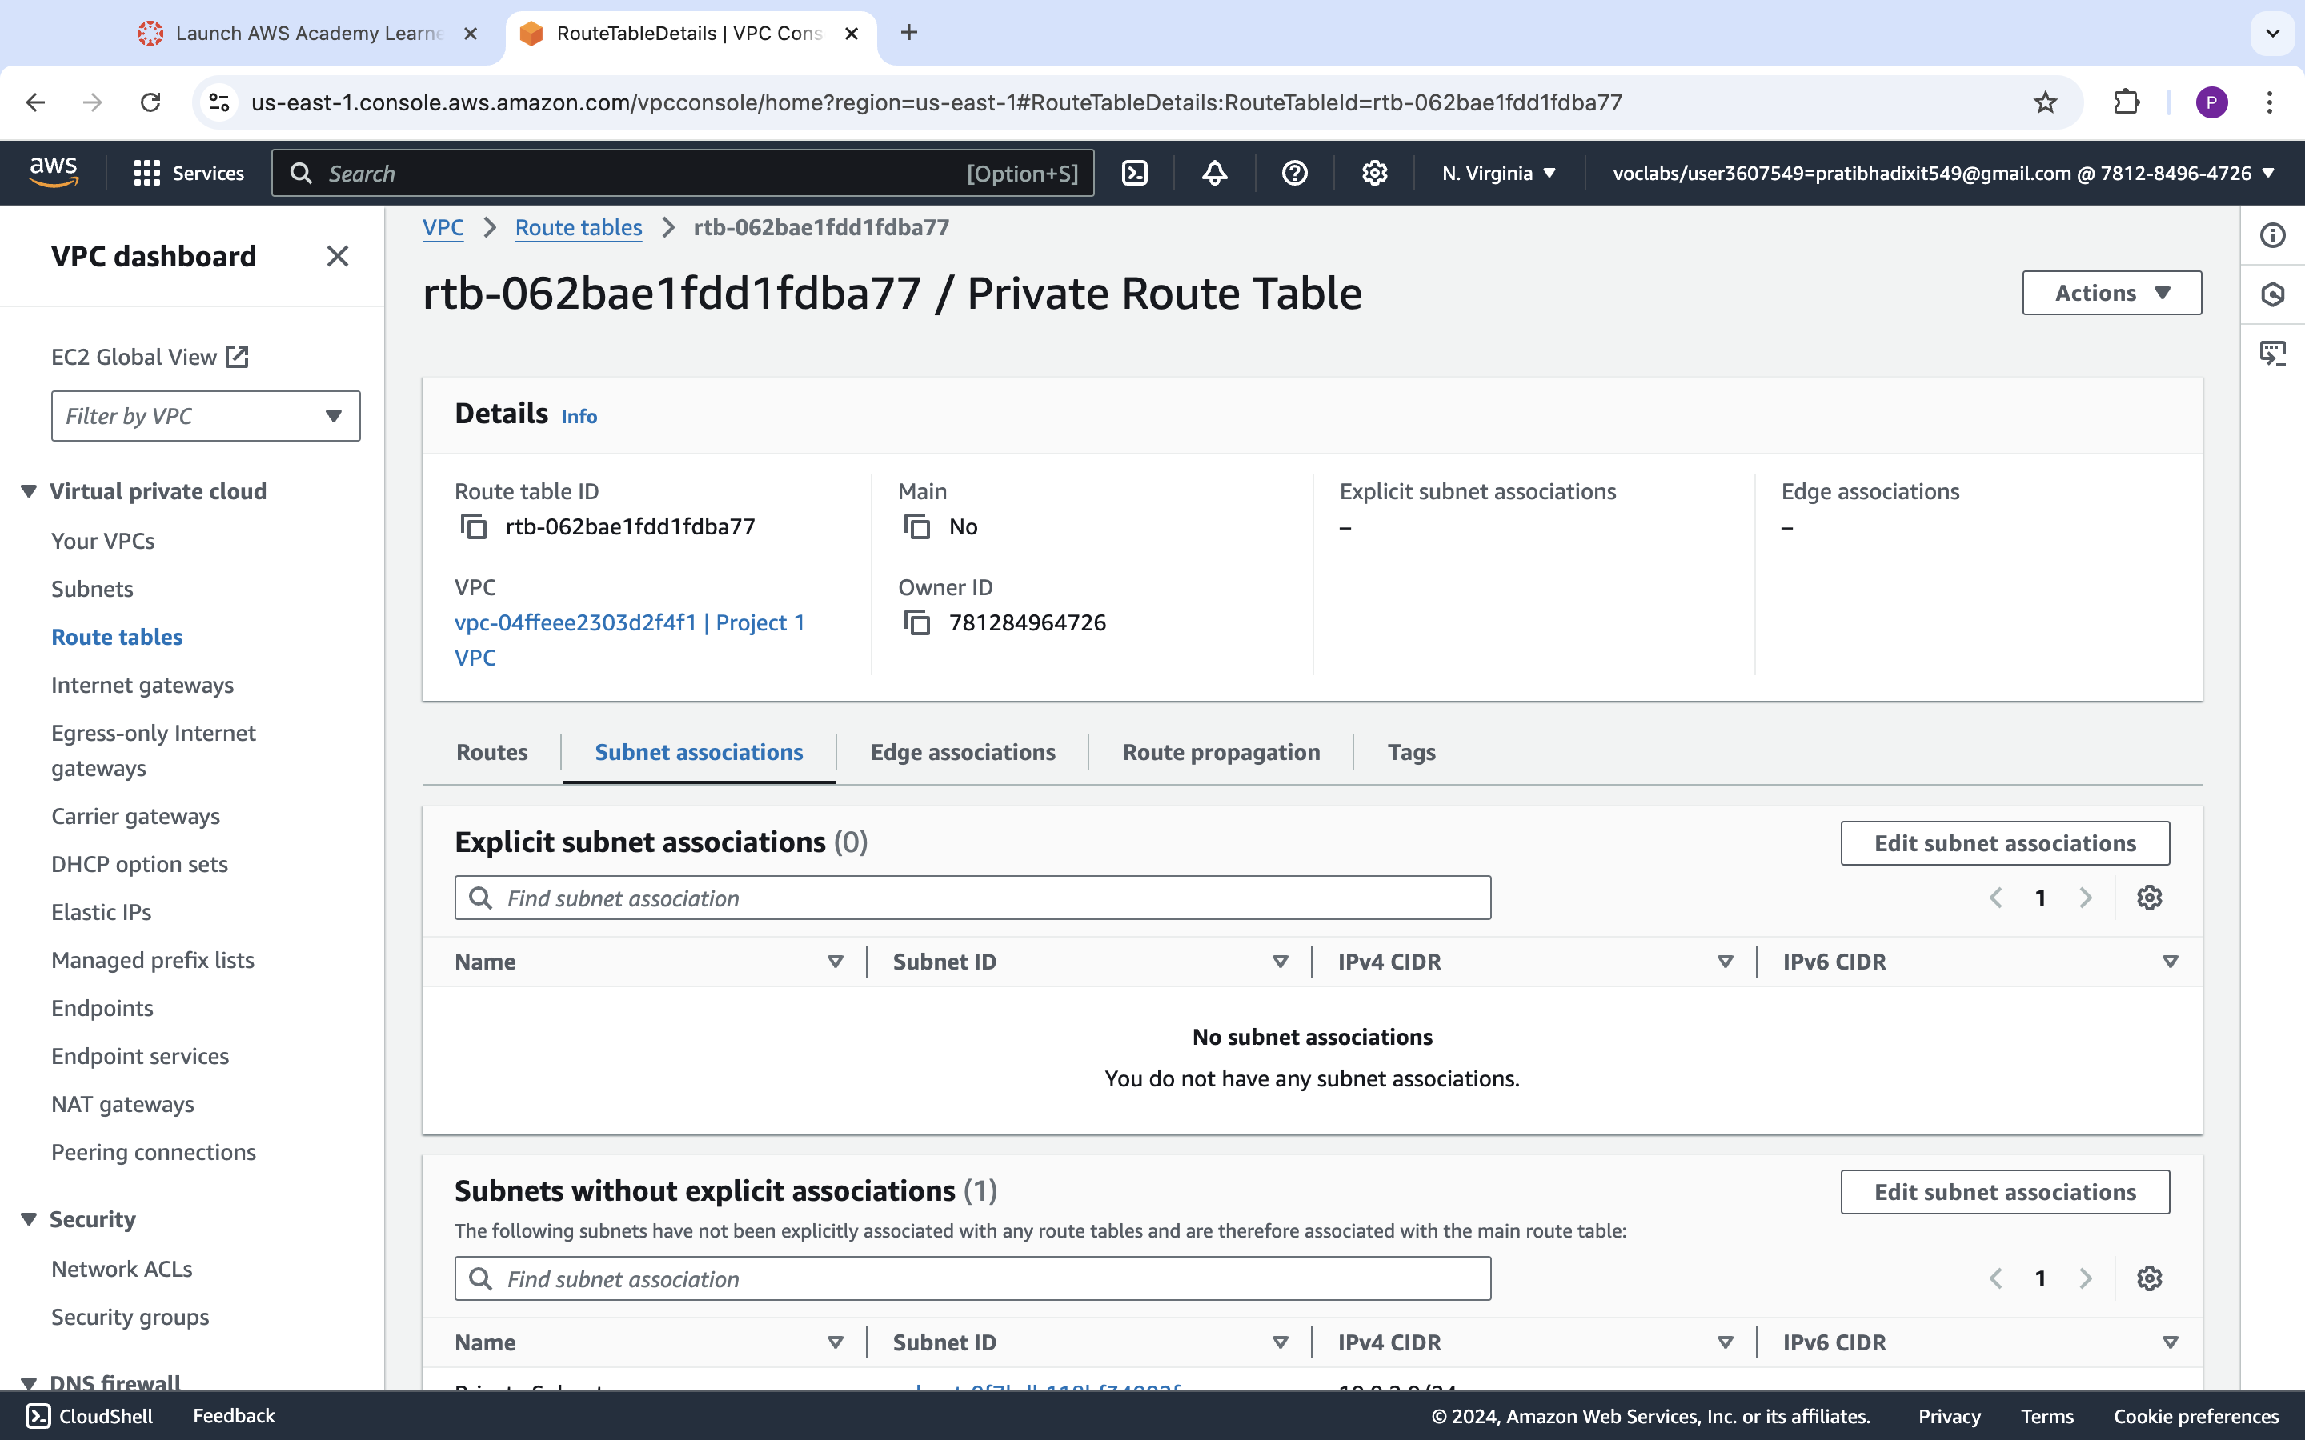

**Screenshot after editing Subnet :**

